NPDC matillion upgrade 1.68.7 to 1.72.4 detail steps

Summary 1

Detail Steps for Development environment 1

Step 1 Verify resources not migrated by Matillion Migration Utility 1

Step 2 Confirm the usage of SQS, CDC or CDC task 4

Step 3 Make sure all developers’ changes are committed and pushed to remote repo. 5

Step 4 Decide if we need to Remove unnecessary version in Matillion VM 1.68 5

Step 5 Advise NPDC data engineer that Matillion upgrade is started 5

Step 6 Stop all Matillion scheduled jobs 5

Step 7 Backup Matillion 1.68 6

Step 8 Install new Matillion VM 1.72.4 6

Step 8.1 Change Matillion VM 1.72.4 password for azure-user 6

Step 8.2 Make sure the TCP/IP connection from Matillion VM 1.68 to Matillion VM 1.72 works 6

Step 8.3 Make sure Matillion VM 1.72 is able to access artifacts.matillion.com 6

Step 8.4 Whitelist IPs address to port 443 and 22 7

Step 8.5 Setup SSO for the new Matillion 7

Step 8.6 Associate Matillion instance to Matillion hub account 7

Step 8.7 Remove the instance shutdown restriction for both the 1.68.7 and 1.72.4 8

Step 9/10 Clone Snowflake DEV_DWH to DEV_DWH_CLONE and assign privileges 8

Step 11 Remove GIT from Matillion ETL 1.68.7 9

Step 12 Go to Matillion ETL 1.68, Admin -> Migrate 9

Step 13 Configure GIT for Matillion 1.72.4 16

Step 14 Update Matillion ETL 1.72.4 variables to connect to DEV_DWH_CLONE 19

Step 15 Create version btg_dev_MatillionUpgrade Matillion ETL 1.72.4 20

Step 16 Apply any customizations on Matillion ETL 1.72 21

Step 17 Run all regular scheduled jobs with DEV_DWH_CLONE database 21

Step 18 Remediate any errors found during the schedule job run 23

Step 19 Update Matillion ETL 1.72.4 variables to connect to DEV_DWH_CLONE 23

Step 20 Run all regular scheduled jobs with DEV_DWH database 23

Step 22 Functional testing for Matillion ETL 1.72.4 24

Step 23 NPDC application testing for Matillion ETL 1.72.4 31

Step 25 Stop Matillion VM 1.68 31

Step 26 Enable HTTPS on Matillion ETL 1.72.4 31

Step 27 Restore Matillion VM shutdown policy (5pm to 7am) 33

Step 28 Re-enable schedules in Matillion VM 1.72.4 34

Step 29 Test scheduled jobs works in Matillion VM 1.72 as expected 34

Detail Steps for Test environment 34

Step 13 Remediate errors and warnings as needed. 34

Detail Steps for Production environment 35

Step 15 Re-enable schedules in Matillion VM 1.72.4 35

TO BE DELETED 37

Step 11 Remove GIT from 1.68.7 37

Step 13 Enable GIT 38

Step Create version and checkout prd_master branch 40

Step 17 Identify any breaking changes 41

Step list of batch jobs in production run for dev environment to run against DEV_DWH_CLONE 41

Step 19 Update Matillion VM 1.72 Environment(s) to refer to the live (DEV) environment rather than the clone one. (i.e development) 43

Step 20 In Matillion VM 1.72, run all regularly scheduled workflows against DEV_DWH database. 45

Reference 1: VM access detail 47

Reference 1: Timetravel setting check 47

# Summary

Between Dec 2023 and Feb 2024, Qrious conducted the Matillion ETL upgrade work for NPDC to bring its Matillion ETL from version 1.68.7 to 1.72.4. This upgrade involves all three instances of Matillion ETL used by NPDC (development, test and production).

In conjunction with the P5377_NPDC Matillion Upgrade – Run Book.xlsx document, this document below lists the detail processes of each step listed in the run book.

# Detail Steps for Development environment

## Step 1 Verify resources not migrated by Matillion Migration Utility

|  |  |
| --- | --- |
| 1 | Make sure the usage of following resources mentioned in <https://docs.matillion.com/metl/docs/migration/> (DEVELOPMENT) |

In conjunction with NPDC team members, we walked through the following list of items and

* Custom licenses.

Confirmed with NPDC data engineer that NO custom licenses is used for NPDC Matillion environment.

* SSL certificates.

SSL certificates are uploaded as Step 26.

* Task history.

Confirmed the acceptance of NO task history data will be migrated with NPDC data engineer.

* Python libraries.

Confirmed with NPDC data engineer that No python libraries is used for NPDC Matillion environment.

.

* Non-standard JDBC drivers

Checked Admin -> Manage Database Drivers and confirmed no

Non-standard JDBC drivers applicable.

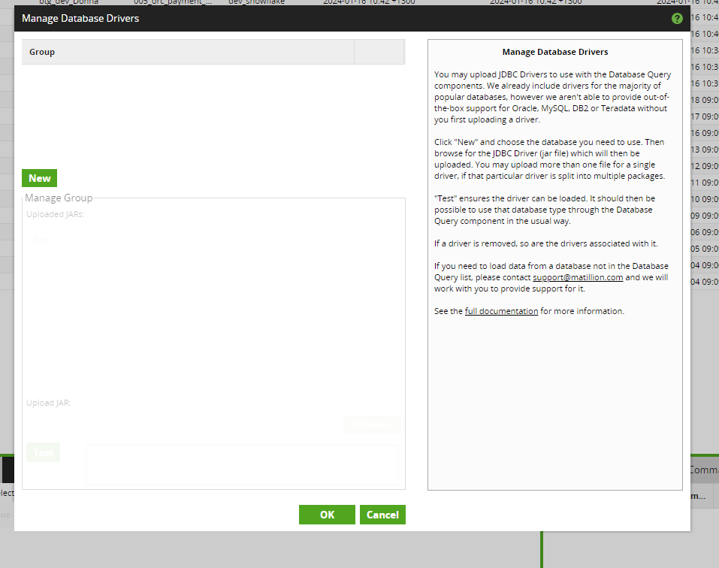

* Customized "standard" API profiles.

Checked and found no customized “standard” API profiles and extract profiles

.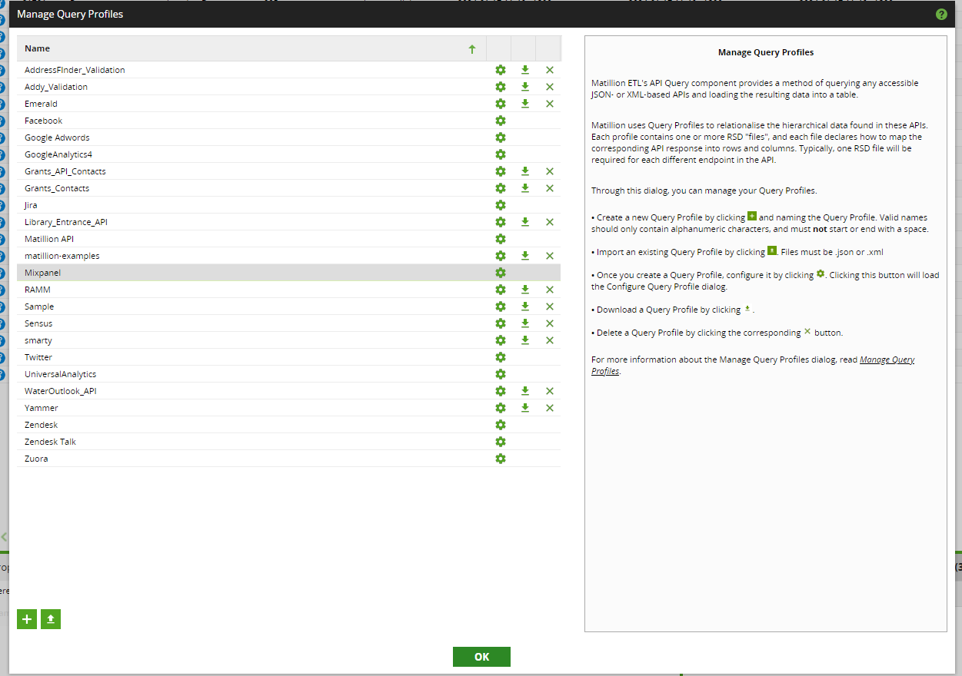

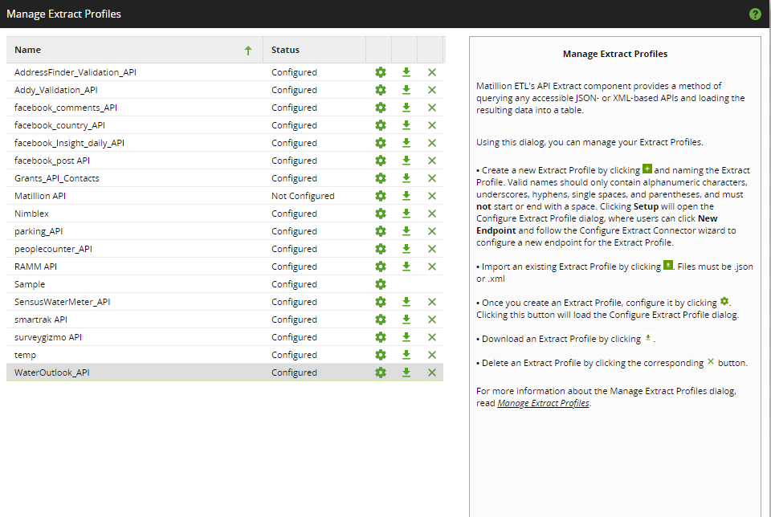

* LDAP setup.

Confirmed with NPDC data engineer that NO custom licenses is used for NPDC Matillion environment.

* Git resources in versions of Matillion ETL prior to 1.61.

hNot applicable as NPDC upgrade from Matillion 1.68

## Step 2 Confirm the usage of SQS, CDC or CDC task

|  |  |
| --- | --- |
| 2 | Make sure the usage of following Matillion function:  SQS queue, CDC, CDC task source creation (DEVELOPMENT) |

* Checked Project -> Manage Queue Configuration and confirmed no queue is used

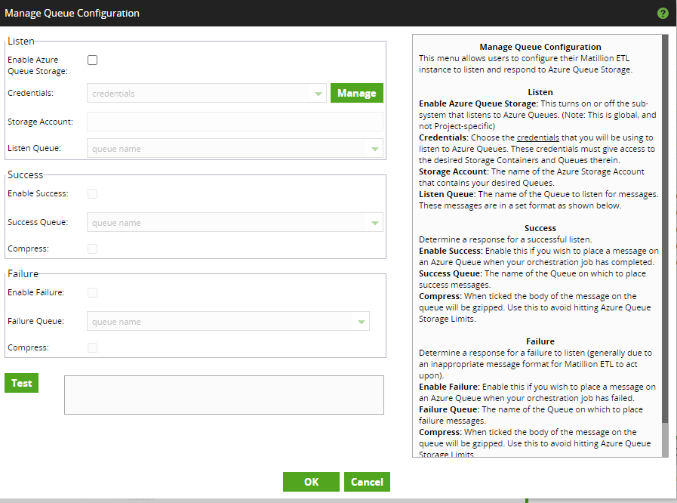

* Confirmed with NPDC data engineer that NO CDC or CDC task is used.

## Step 3 Make sure all developers’ changes are committed and pushed to remote repo.

* Confirmed with NPDC data engineer that all changes are committed and pushed to remote repo.

## Step 4 Decide if we need to Remove unnecessary version in Matillion VM 1.68

* Unnecessary versions may slow down the migration process (<https://community.matillion.com/s/question/0D5Tm000002hj2CKAQ/migrating-matillion-etl-1598-to-1730-but-migrate-utility-gets-stuck-help>)
* Discussed with NPDC data engineer and decided to keep all versions (around 10 of the versions) when entering the migration process. If hitting issue during the migration process, we will revisit this option and reduce the number of versions by then.
* During the development migration, we encountered an issue as documented in the URL above; the migration process became unresponsive and did not proceed. We removed 6 of the versions and restarted the process, this time the migration completed successfully.

## Step 5 Advise NPDC data engineer that Matillion upgrade is started

* NPDC data engineer is advised that Matillion upgraded is started.

## Step 6 Stop all Matillion scheduled jobs

* Checked Porject -> Managed Schedules and there is no active scheduled job.

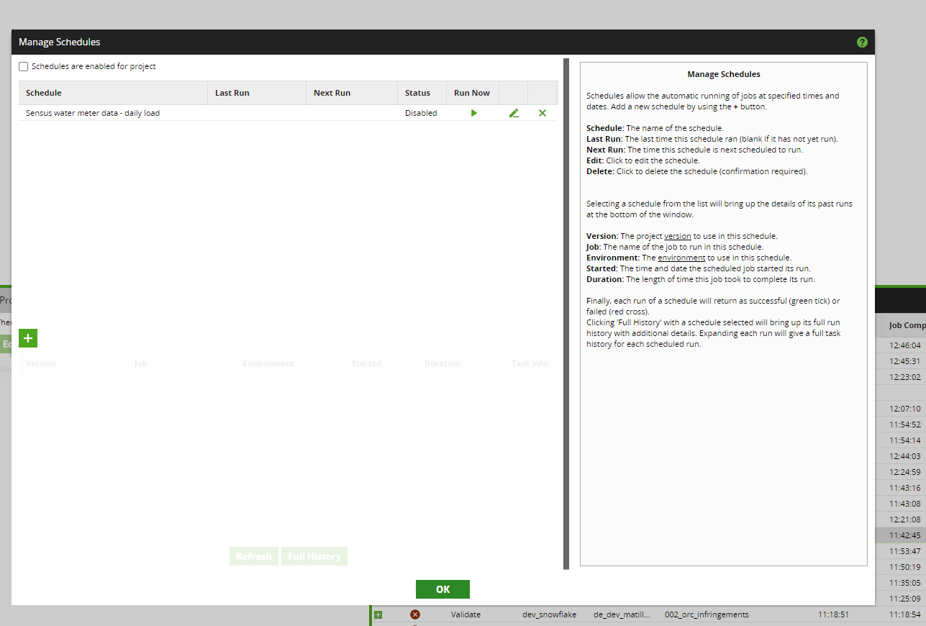

Step 7 Backup Matillion 1.68

Azure portal > Virtual machine > Backup > Backup now > Fill the Retain back till then Ok

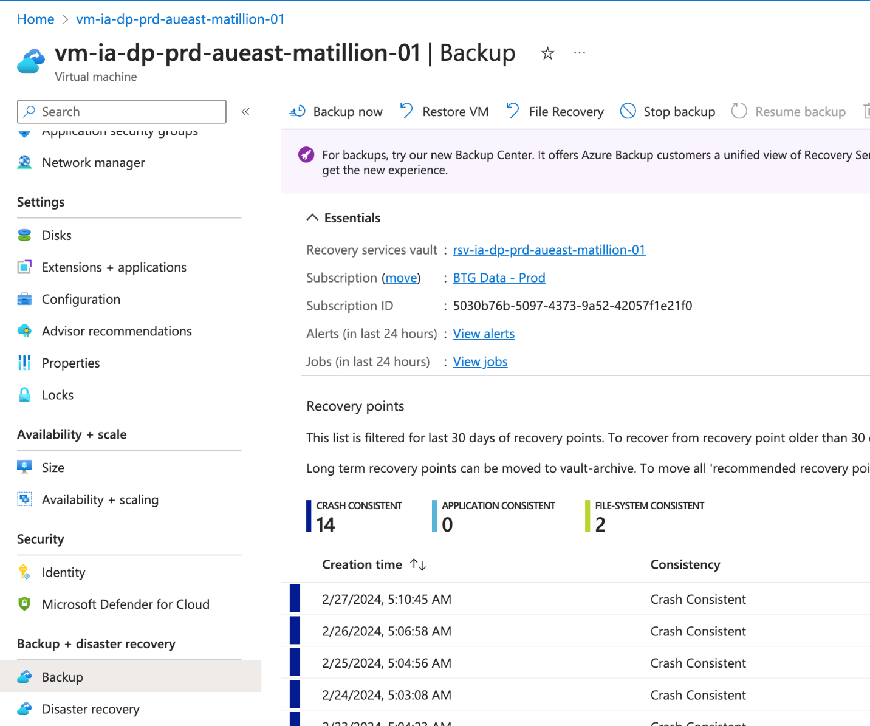

## Step 8 Install new Matillion VM 1.72.4

Azure DevOps > Pipelines > BTG DataPlatform - Matillion 02 > Run pipeline > Select the branch, environment and terraform action then Run

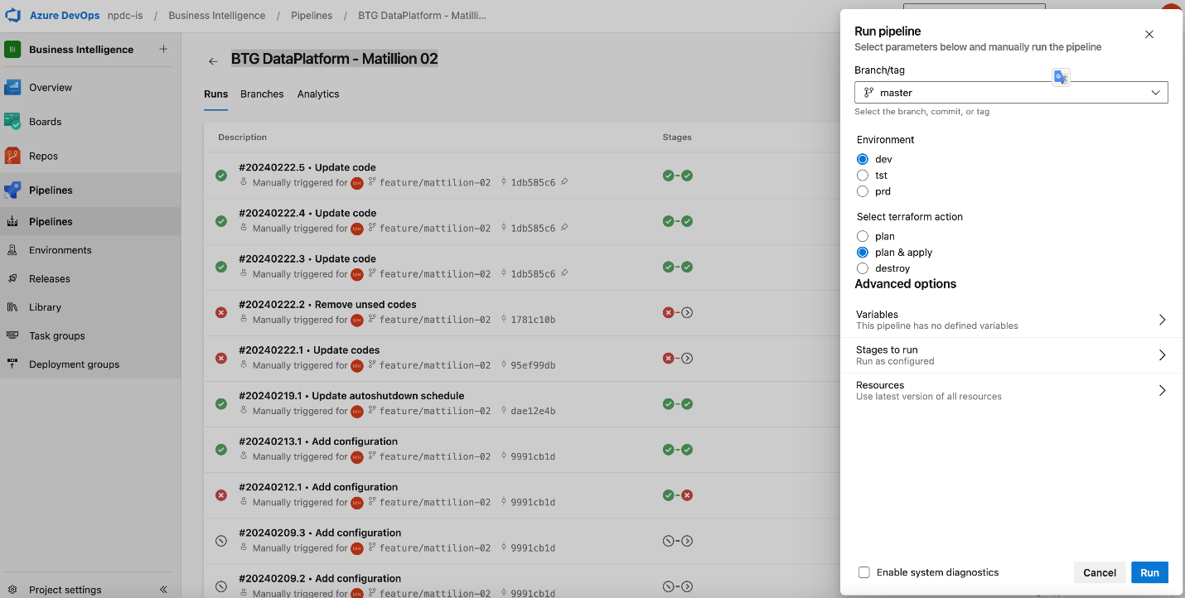

## Step 8.1 Change Matillion VM 1.72.4 password for azure-user

Login to <https://matillion.npdc.govt.nz/> > Admin > User > Select the azure-user then change password

## Step 8.2 Make sure the TCP/IP connection from Matillion VM 1.68 to Matillion VM 1.72 works

If the new and old Matillion are in the same Vnet subnet then the connectivity between them just works fine

## Step 8.3 Make sure Matillion VM 1.72 is able to access artifacts.matillion.com

If the new and old Matillion are in the same Vnet subnet then the connectivity to artifacts.matillion.com just work fine

## Step 8.4 Whitelist IPs address to port 443 and 22

Azure portal > Subscription > rg-ia-dp-prd-aueast-base-01 resource group > vnet-ia-dp-prd-aueast-01 > Subnets > snet-ia-dp-prd-aueast-public-01 > security group

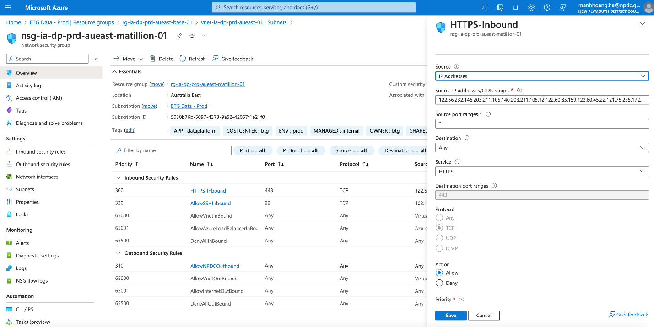

## Step 8.5 Setup SSO for the new Matillion

Please follow this documentation to setup SSO <https://docs.matillion.com/metl/docs/2945144/#managing-users-and-logging-in-with-openid-credentials>

## Step 8.6 Associate Matillion instance to Matillion hub account

When accessing the new Matillion 1.72.4 application for the first time, it prompts you to associate this instance with the NPDC Matillion Hub, as illustrated in the screenshot below.

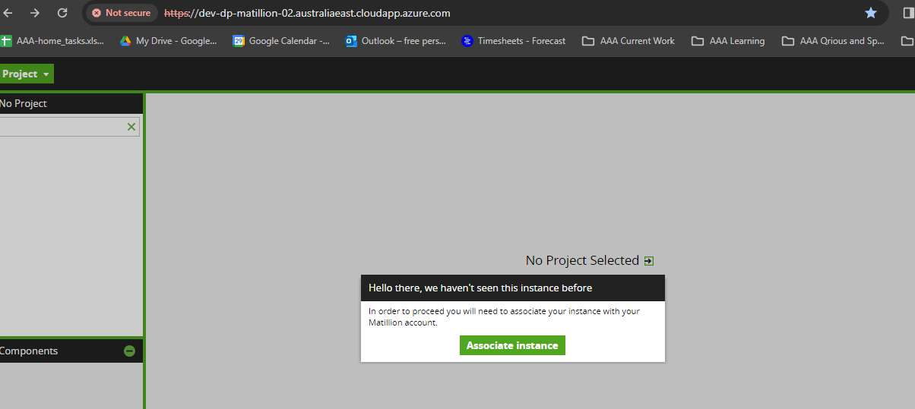

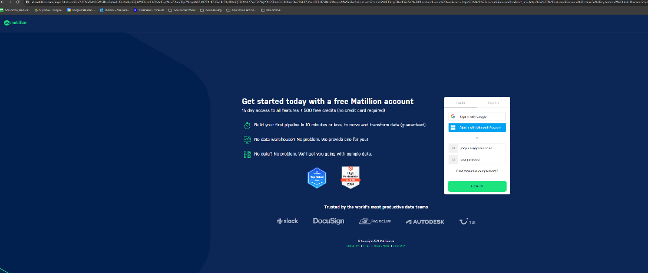

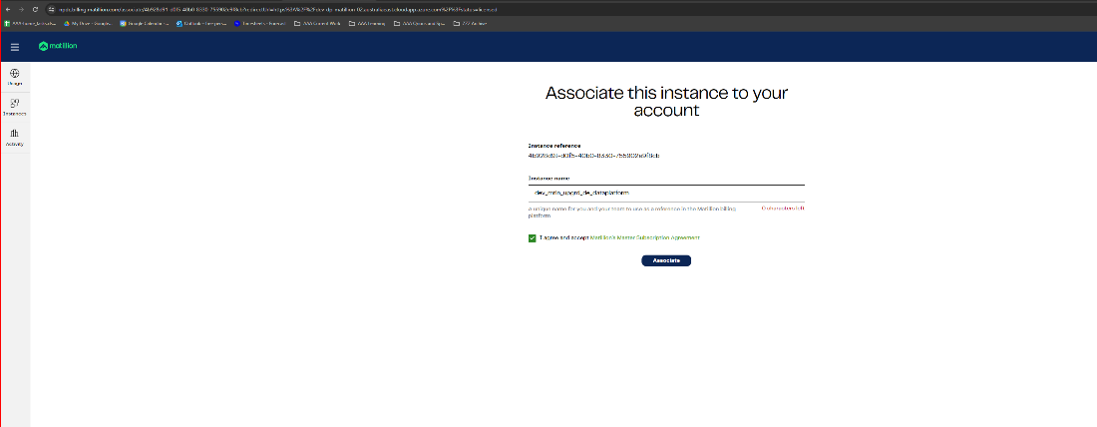

## Step 8.7 Remove the instance shutdown restriction for both the 1.68.7 and 1.72.4

There is a rule for the VM to shutdown between 5pm and 7am. The migration and checking process may run over 5pm, therefore, we need to remove this rule during the migration period.

Ask Manh to provide details.

## Step 9/10 Clone Snowflake DEV_DWH to DEV_DWH_CLONE and assign privileges

* Below is the SQL script for this step



## Step 11 Remove GIT from Matillion ETL 1.68.7

* Initially, we followed the Matillion migration document <https://docs.matillion.com/metl/docs/migration/> trying to migrate with GIT. However, once the first migration is done and we logged into the Matillion ETL 1.72.4 environment, we noticed that GIT function is not migrated.
* We then contacted with Matillion support and raised case <https://support.matillion.com/s/case/500Tm000003ITWVIA4/matillion-etl-migration-from-1687-to-1734-but-git-configuration-is-not-migrated>
* Based on the advice from the support case, we followed below link <https://support.matillion.com/s/article/How-To-Removing-Git-From-A-Project> to remove GIT integration from our Matillion 1.68.7 environment and below is the log of our removal



## Step 12 Go to Matillion ETL 1.68, Admin -> Migrate

The following screenshots show the process of migration from Matillion ETL 1.68.7 to Matillion ETL 1.72.4.

Initially, we migrate with all the versions we had in 1.68.7 (about 10 versions), then we hit the issue of the migration hung for quick a while (over 60 minutes), this aligns the issue discussed in Step 4, hence we decided to only retain 4 versions and restarted the migration process. After this change, the migration process is completed in 5 minutes time.

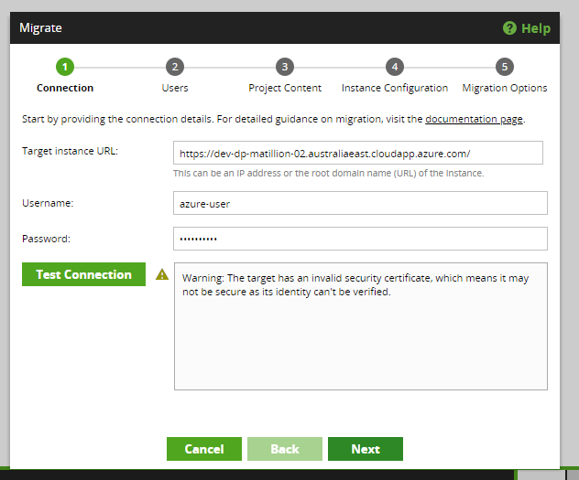

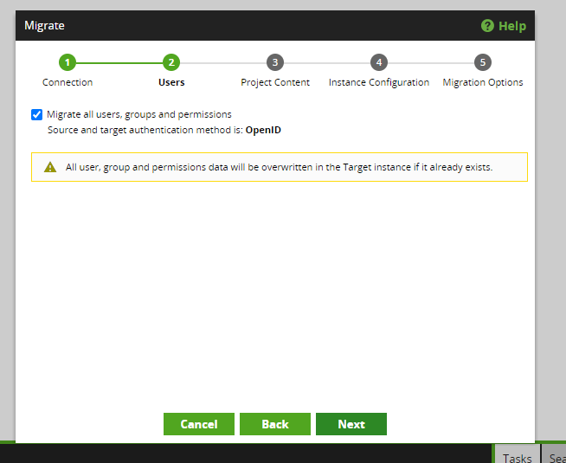

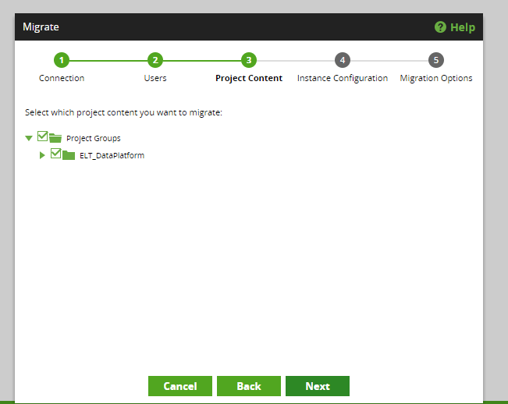

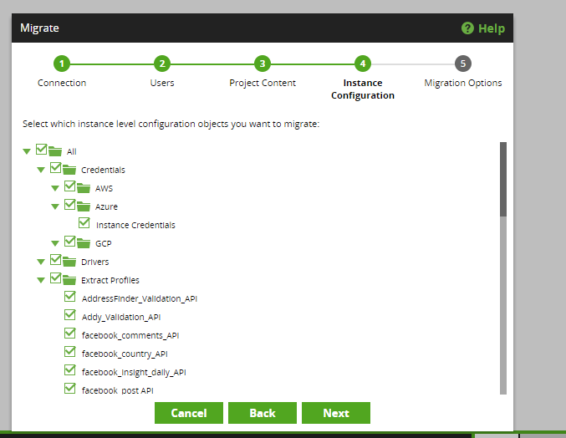

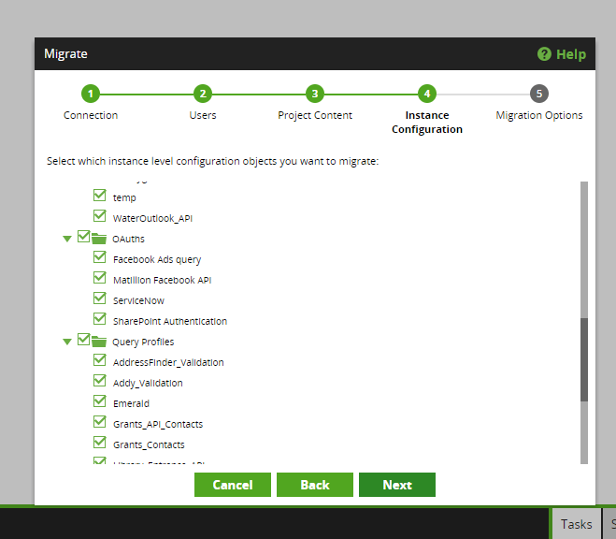

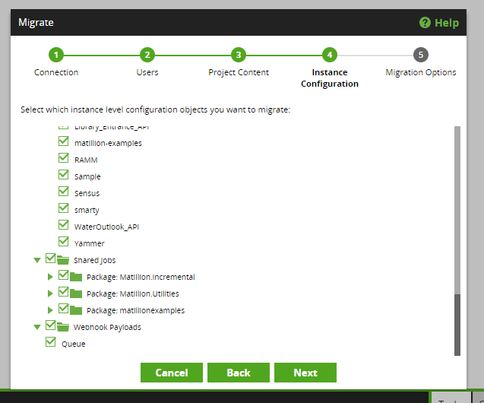

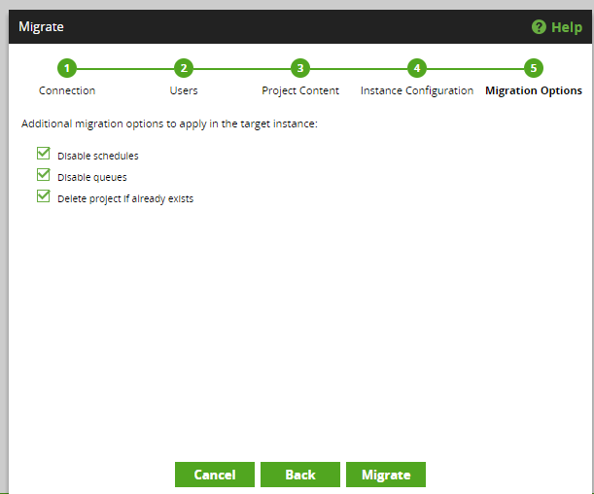

* After the migration is completed, we have the following output from Matillion migration utility. All 4 warnings are checked and none of them need to be attended.

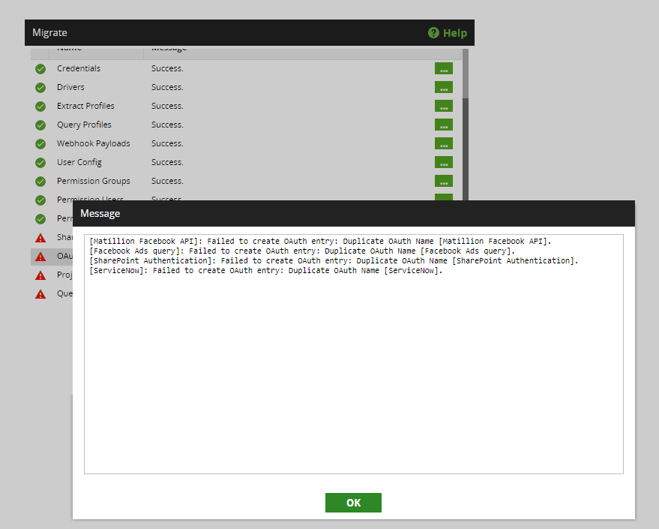

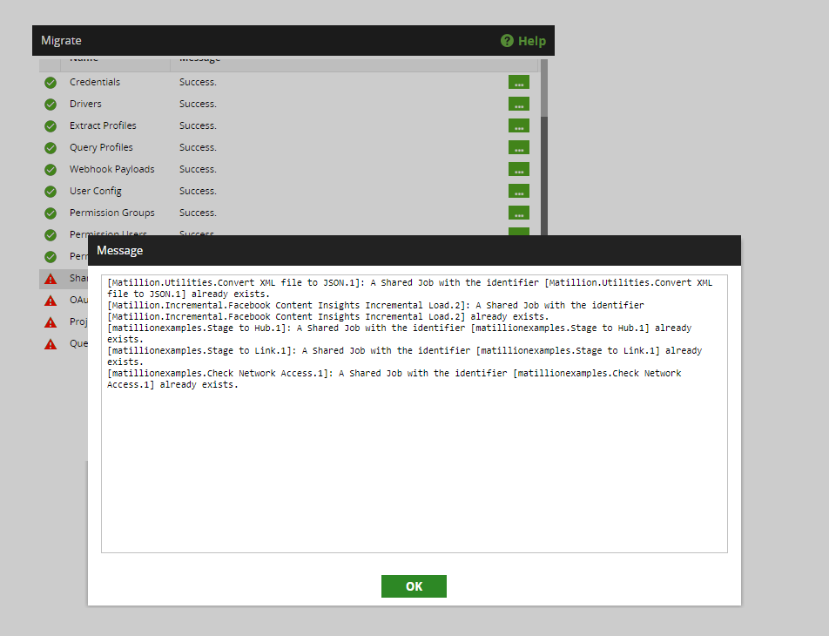

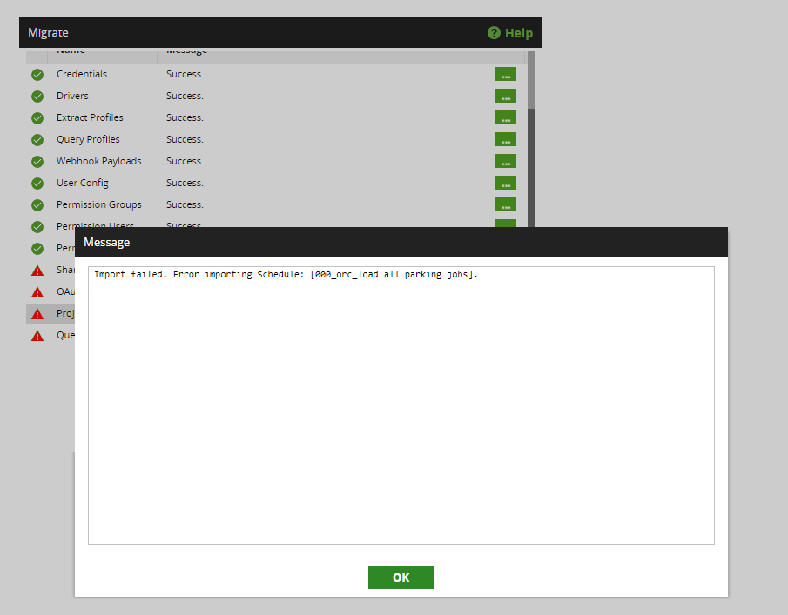

## Step 13 Configure GIT for Matillion 1.72.4

We integrated Matillion 1.72.4 with GIT

* + From Matillion migration document, it mentions

“When you perform a migration with Git enabled, commits for orchestration and transformation jobs in every project in the target instance will be flagged as Modified. You will need to perform a one-time commit of all jobs after the migrate, which will remove the Modified flag. This is expected behavior, due to some of the formats of the jobs changing during the upgrade, and isn't a cause for concern. These are valid changes to the structure of the jobs and you can commit them safely.”.

However, as we migrated without GIT, this “one-time commit” does not apply to us.

* + The GIT repo for NPDC Matillion is <https://dev.azure.com/npdc-is/Business%20Intelligence/_git/matillion_btg_dataplatform>
  + Every developer needs to follow the below process to setup his/her own GIT configuration.

sGo to Project menu -> GIT -> Clone Repository

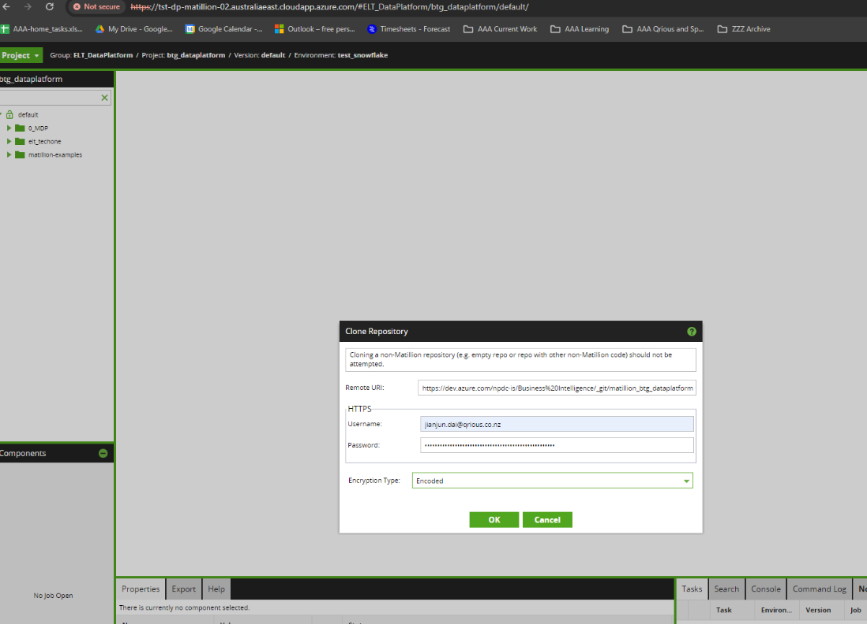

For the access credentials, please see the section below of Create Access Token.

* + Create Access Token. The access token is created by [jianjun.dai@npdc.govt.nz](mailto:jianjun.dai@npdc.govt.nz), this may need to be changed to NPDC internal team member.

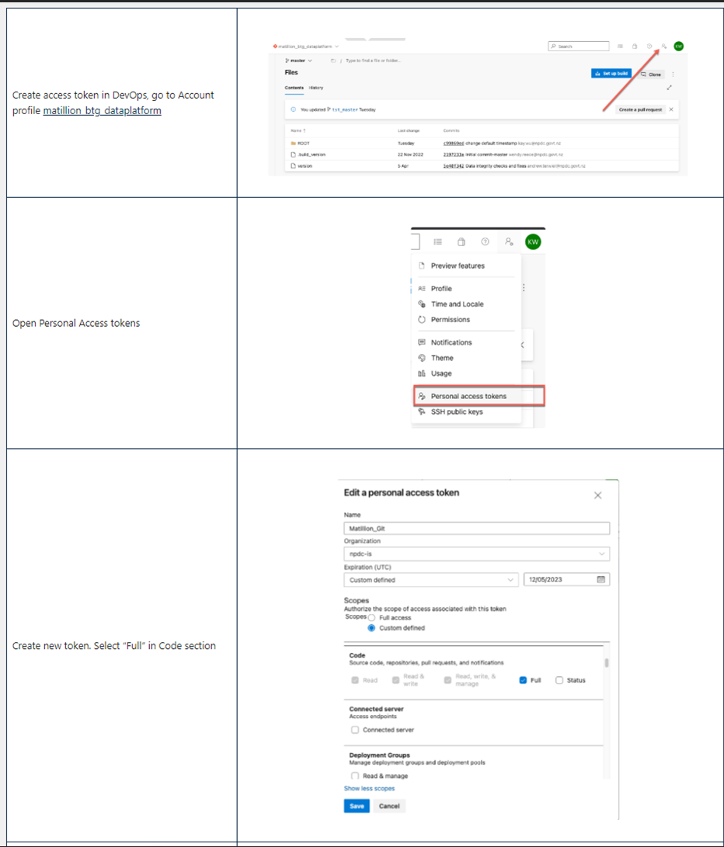

* + Config GIT credentials

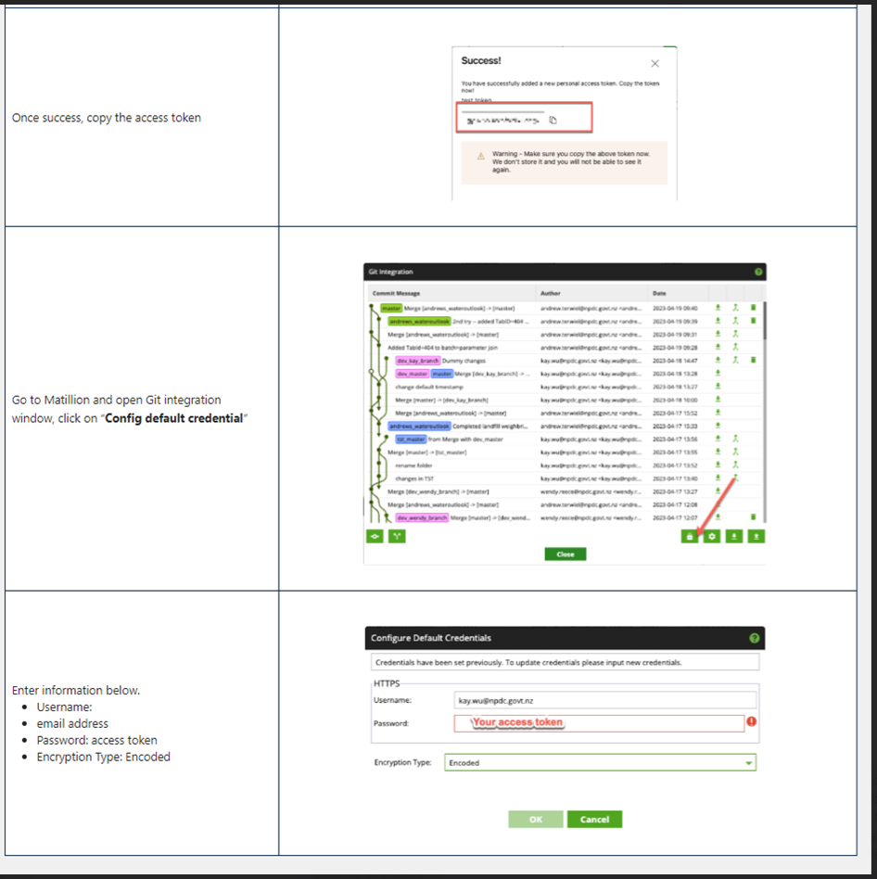

## Step 14 Update Matillion ETL 1.72.4 variables to connect to DEV_DWH_CLONE

This is to allow us to run Matillion jobs with our cloned database DEV_DWH_CLONE.

* Go to Environments -> edit environment dev_snowflake to change default database to DEV_DWH_CLONE

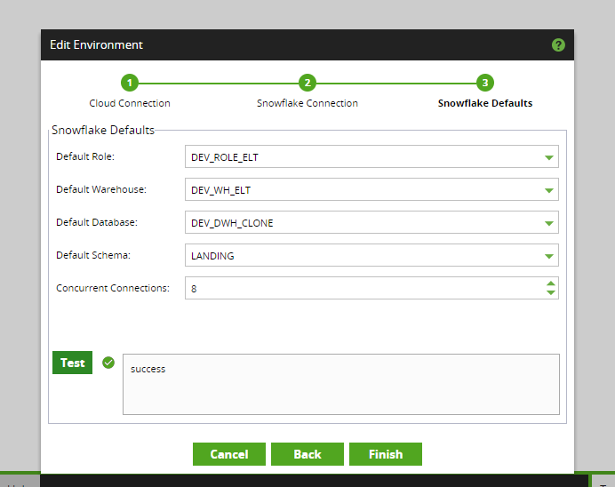

* Go to Manage Variables and change ev_metadata_database to DEV_DWH_CLONE

## Step 15 Create version btg_dev_MatillionUpgrade Matillion ETL 1.72.4

* The below screenshot shows the version btg_dev_MatillionUpgrade is created. Once it is created, switch to this version and checkout dev_master from GIT to get ready for batch run testing.

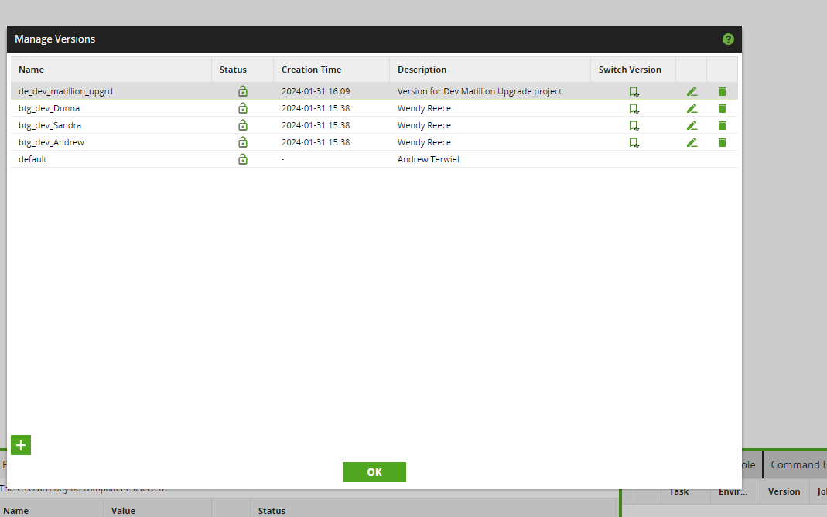

## Step 16 Apply any customizations on Matillion ETL 1.72

This step is not applicable as there is no customization need to apply.

## Step 17 Run all regular scheduled jobs with DEV_DWH_CLONE database

* 005_orc_payment_claims
  + The first time clicking off this job failed due to API extract error. This is due to the new VM dev-dp-matillion-02.australiaeast.cloudapp.azure.com is not allowed to access Azure storage location stiadpdevadls01.
  + Once engineer resolved this problem, the job completed successfully.
* 000_orc_parking_daily_job_loads
  + Completed successfully
* 001_orc_bluecloud_extractor
  + Completed successfully
* 001_orc_library_daily_job_loads
  + Got error Insufficient privileges to operate on table 'LIBRARY_EXT_PEOPLECOUNTER'. This error occurred when running it in Matillion 1.68.7 environment with DEV_DWH database, this is suspected because LANDING.LIBRARY_EXT_PEOPLECOUNTER is owned by ACCOUNTADMIN role while Matillion run as DEV_ETL_ROLE role, which has no right to operate on this table.
* 002_orc_scada_data_daily_main
  + Completed successfully
* 001_orc_Landfill_Weighbridge_main
  + Completed successfully
* 001_orc_daily_papercut_loads
  + Completed successfully
* 000_orc_ramm_daily_job_loads
  + Completed successfully
* 001_orc_grants_daily_job_loads
  + Completed successfully
* 002_orc_kerbside_waste_main
  + Completed successfully
* 001_orc_sensus_load_transformation
  + Completed successfully
* 000_orc_facebook_daily_job_loads
  + The job runs successfully after
    - update dev_dwh_clone.DATASTORE.FACEBOOK_FACT_STATS_COUNTRY set datekey = 20240115 where datekey = 20230720;
    - It looked like for a too long period of time (eg from 20230720 to 20240202), the job is no able to run successfully.
    - Recreate external function DEV_DWH_CLONE.DATASTORE."CALCULATE_SENTIMENT"("STR" VARCHAR(16777216)) from its definition in DEV_DWH, as Snowflake zero copy cloning does not support clone external function.
* dj_00_orc_run_techone_daily
  + Completed successfully after 9 hours and 15 minutes
* 001_orc_matillion_job_history_extraction
  + Completed successfully
* 001_orc_failed_jobs_notification
  + Completed successfully

## Step 18 Remediate any errors found during the schedule job run

No Matillion job error found during Step 17.

## Step 19 Update Matillion ETL 1.72.4 variables to connect to DEV_DWH_CLONE

This step reverts the database connection from DEV_DWH_CLONE to DEV_DWH and allows us to run Matillion jobs with database DEV_DWH.

* Go to Environments -> edit environment dev_snowflake to change default database to DEV_DWH

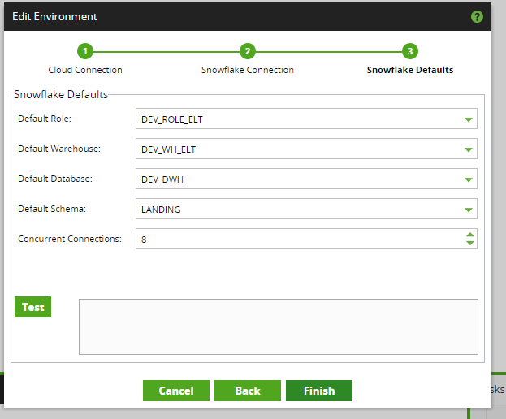

* Go to Manage Variables and change ev_metadata_database to DEV_DWH

## Step 20 Run all regular scheduled jobs with DEV_DWH database

* 005_orc_payment_claims
  + Completed successfully
* 000_orc_parking_daily_job_loads
  + Completed successfully
* 001_orc_bluecloud_extractor
  + Completed successfully
* 001_orc_library_daily_job_loads
  + Got error Insufficient privileges to operate on table 'LIBRARY_EXT_PEOPLECOUNTER'. This error occurred when running it in Matillion 1.68.7 environment with DEV_DWH database, this is suspected because LANDING.LIBRARY_EXT_PEOPLECOUNTER is owned by ACCOUNTADMIN role while Matillion run as DEV_ETL_ROLE role, which has no right to operate on this table.
* 002_orc_scada_data_daily_main
  + Completed successfully
* 001_orc_Landfill_Weighbridge_main
  + Completed successfully
* 001_orc_daily_papercut_loads
  + Completed successfully
* 000_orc_ramm_daily_job_loads
  + Completed successfully
* 001_orc_grants_daily_job_loads
  + Completed successfully
* 002_orc_kerbside_waste_main
  + Completed successfully
* 001_orc_sensus_load_transformation
  + Completed successfully
* 000_orc_facebook_daily_job_loads
  + The job runs successfully after
    - update dev_dwh_clone.DATASTORE.FACEBOOK_FACT_STATS_COUNTRY set datekey = 20240115 where datekey = 20230720;
    - It looked like for a too long period of time (eg from 20230720 to 20240202), the job is not able to run successfully.
* dj_00_orc_run_techone_daily
  + Completed successfully after 9 hours and 15 minutes
* 001_orc_matillion_job_history_extraction
  + Completed successfully
* 001_orc_failed_jobs_notification
  + Completed successfully

## Step 22 Functional testing for Matillion ETL 1.72.4

* Create user account

Created user matillion_upgrade_test_user and can login with this user into Matillion ETL 1.72.4. Deleted this user after testing.

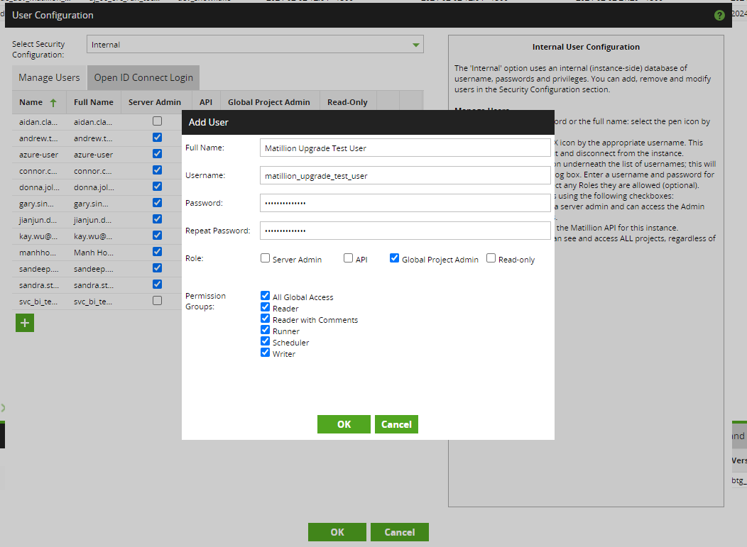

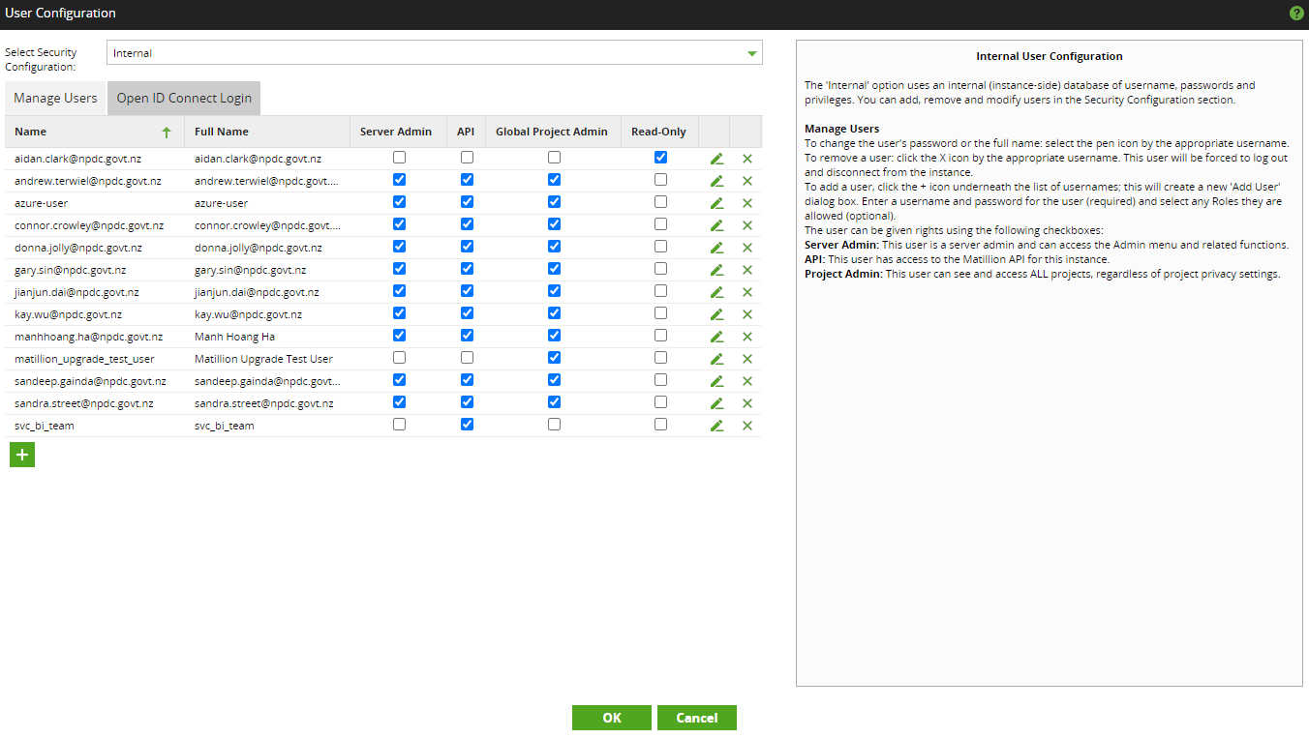

* Create version

Created version de_dev_matillion_upgrd

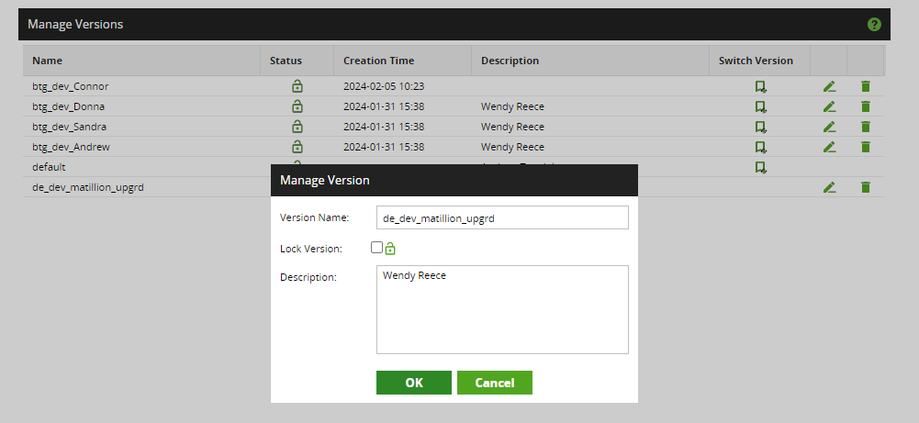

* Create transformation job

Created transformation job Matillion_upgrade_test_transform to read data using table input component from table "DEV_DWH"."LANDING"."NIMBLEX_CONTRACTS".

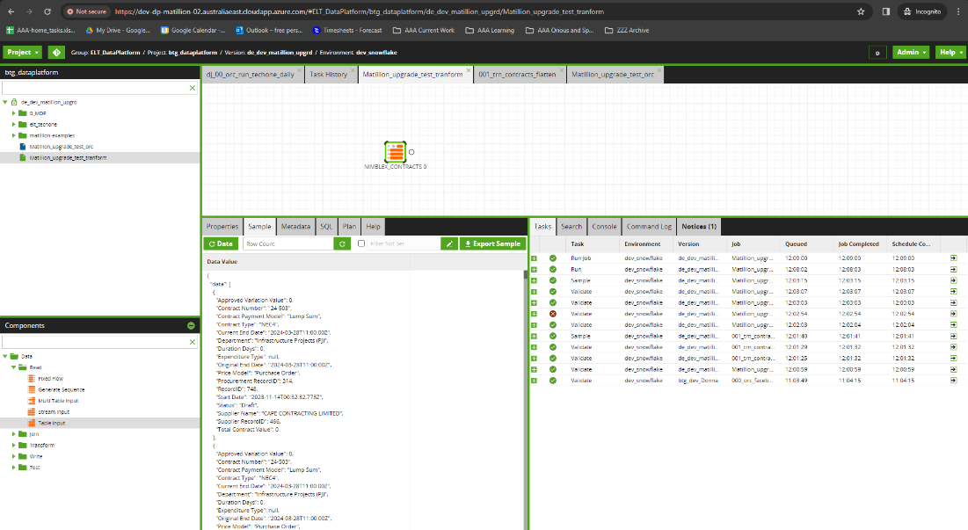

* Create orchestration job

Created orchestration job Matillion_upgrade_test_orc to execute transformation job Matillion_upgrade_test_transform.

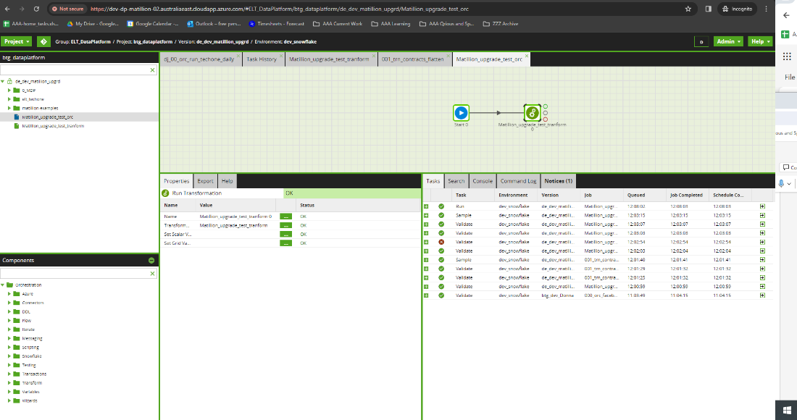

* GIT integration
  + Created branch dev_matillion_upgrade_test from dev_master

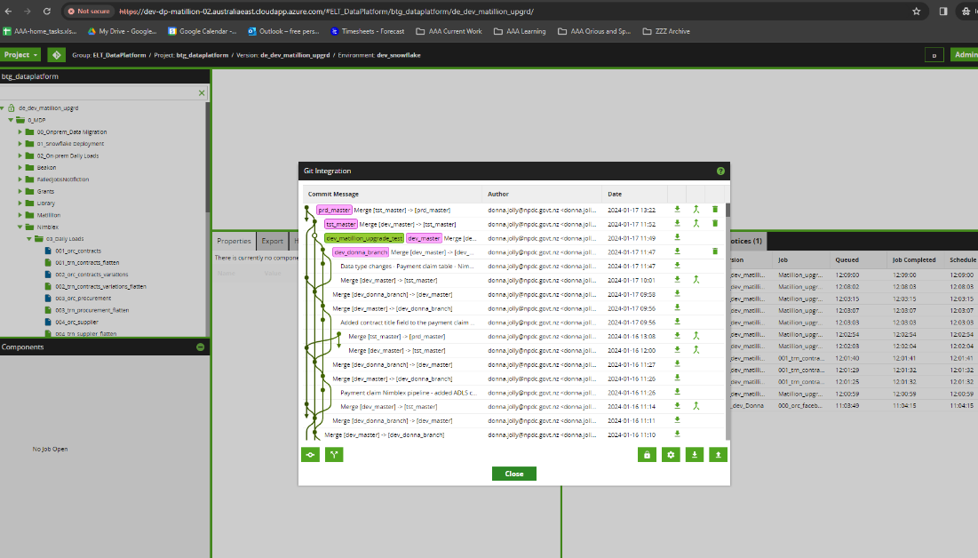

* + Committed changes to dev_matillion_upgrade_test branch

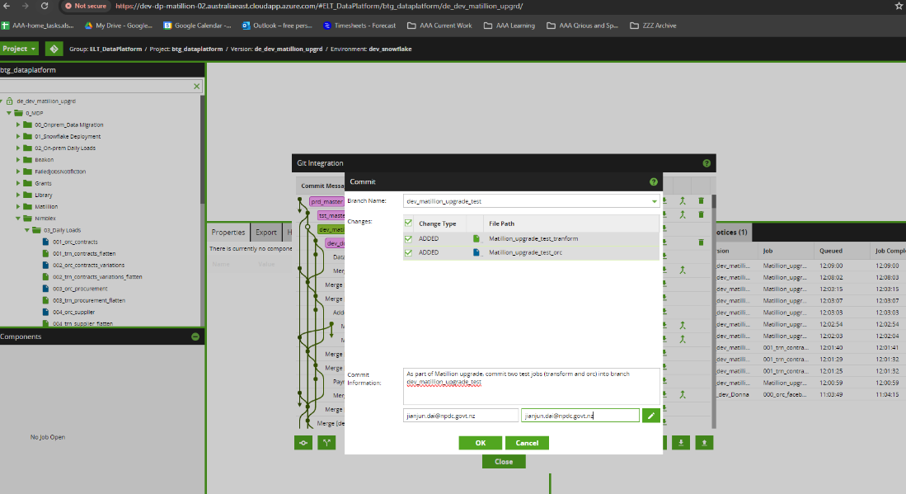

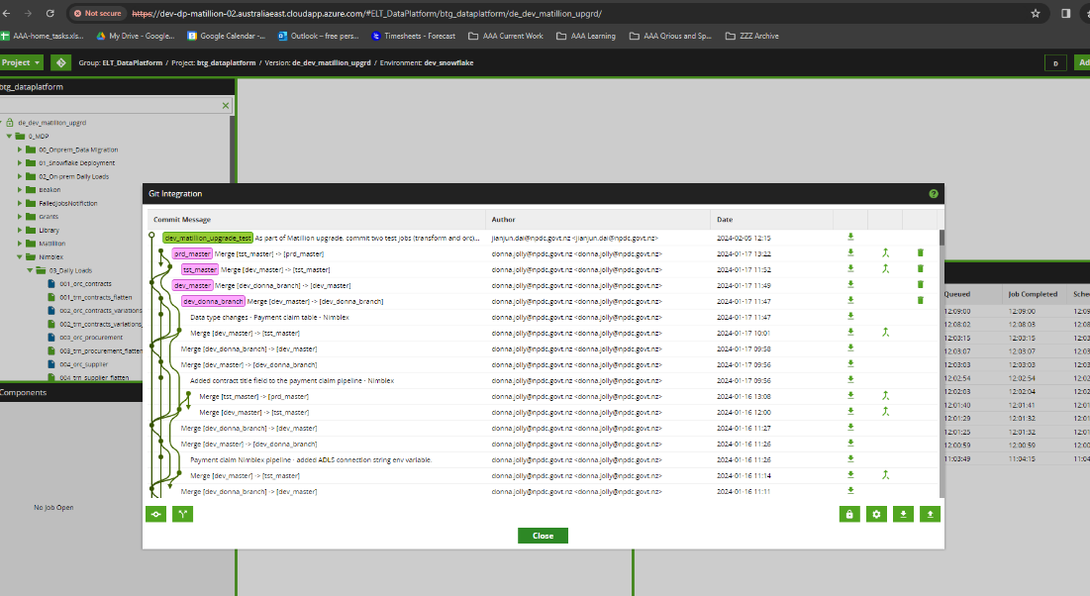

* + Git Integration -- Push All

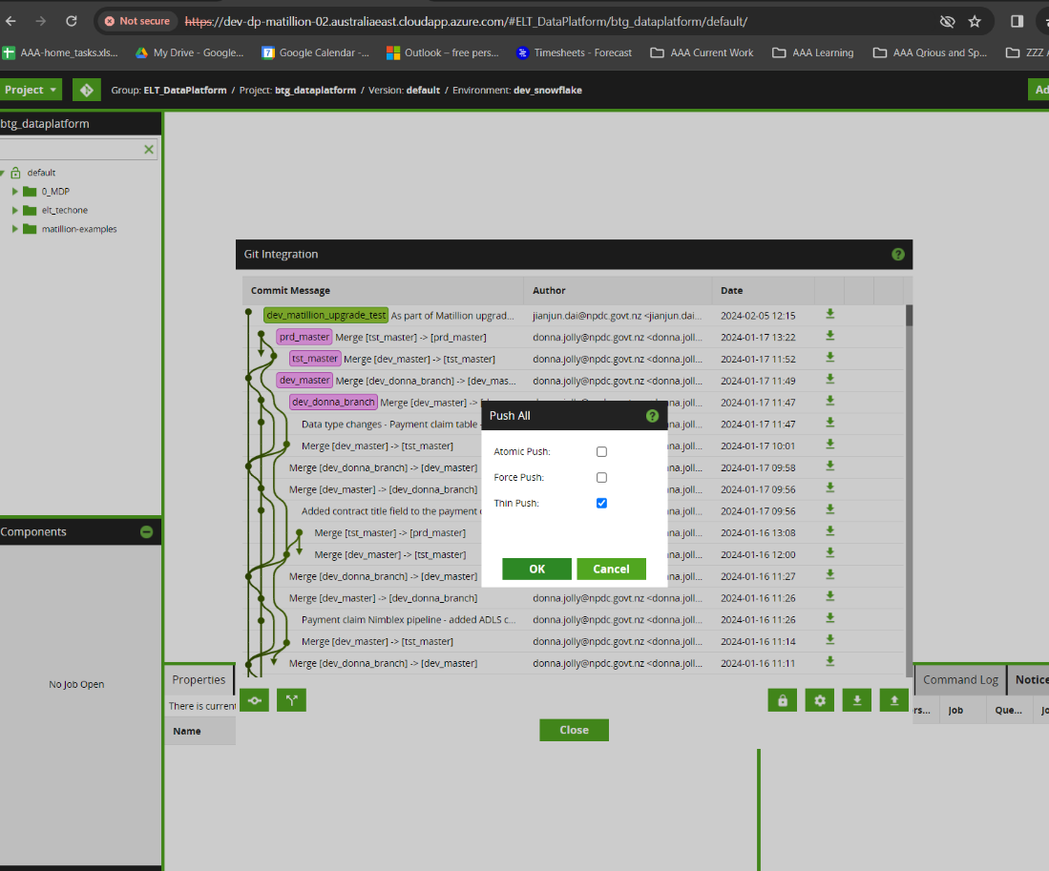

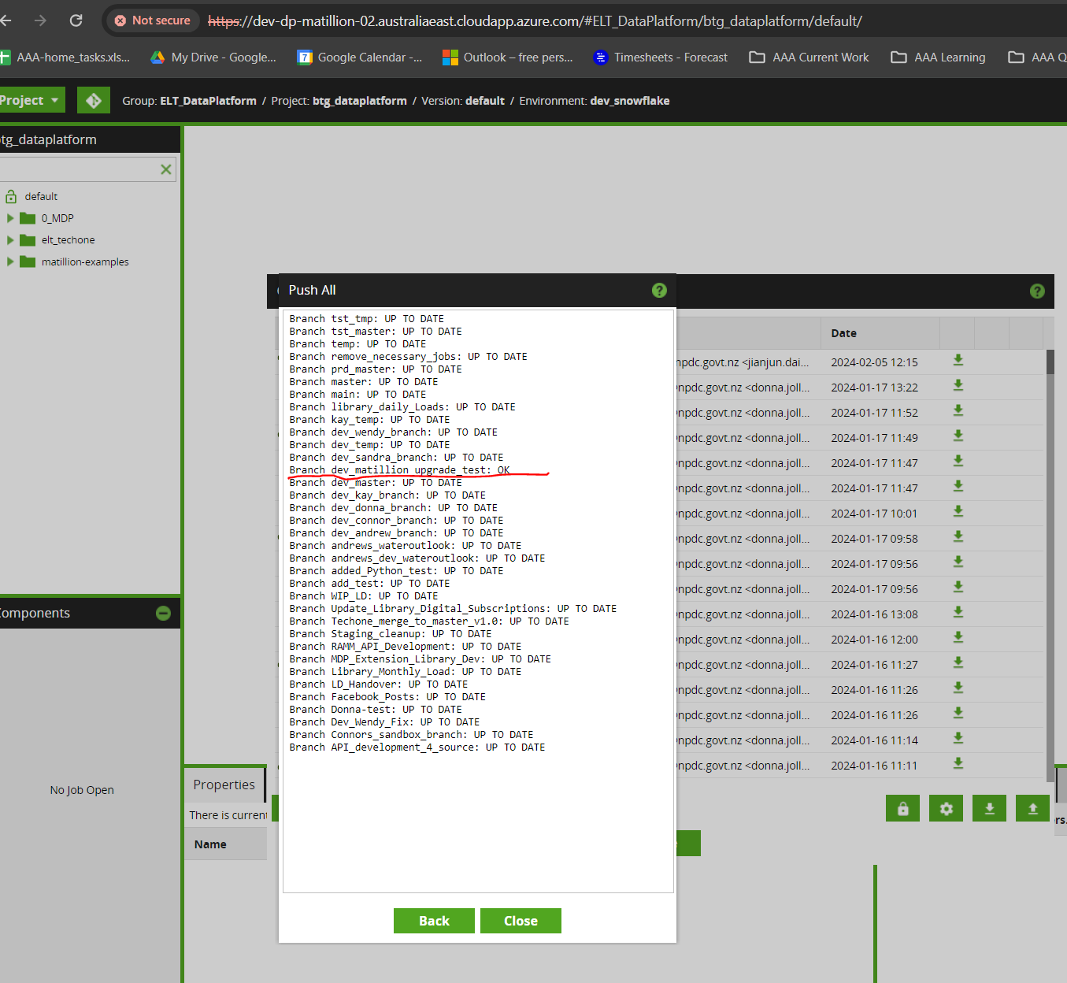

* + Git Integration – Fetch

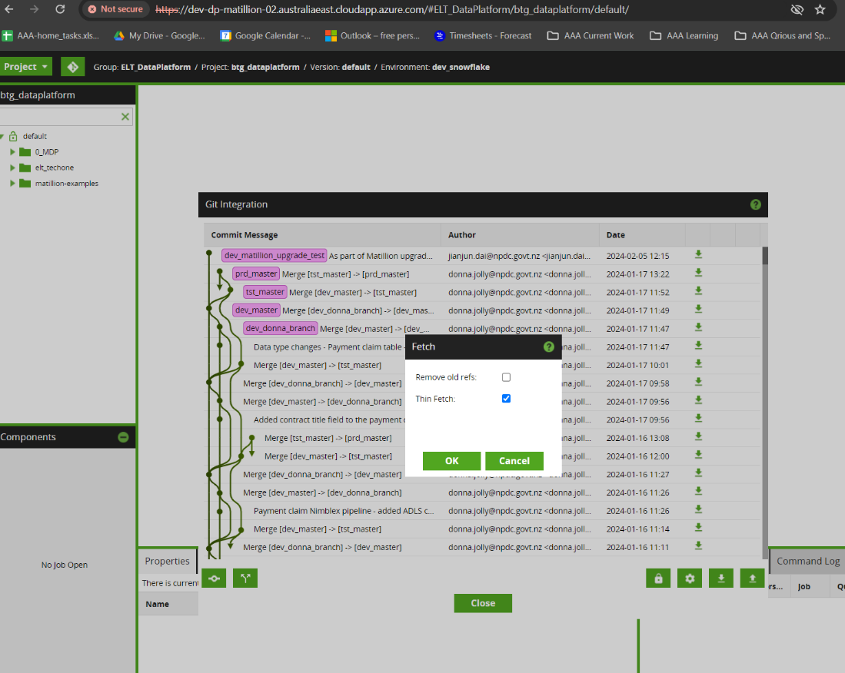

## Step 23 NPDC application testing for Matillion ETL 1.72.4

This step involved asking NPDC data engineers to verify the migrated Matillion ETL 1.72.4 environment work as expected.

Step 24 Swap DNS between the original and new Matillion dev instances

Ask NPDC to provide detail.

## Step 25 Stop Matillion VM 1.68

Azure portal > Virtual machine > Overview > Stop

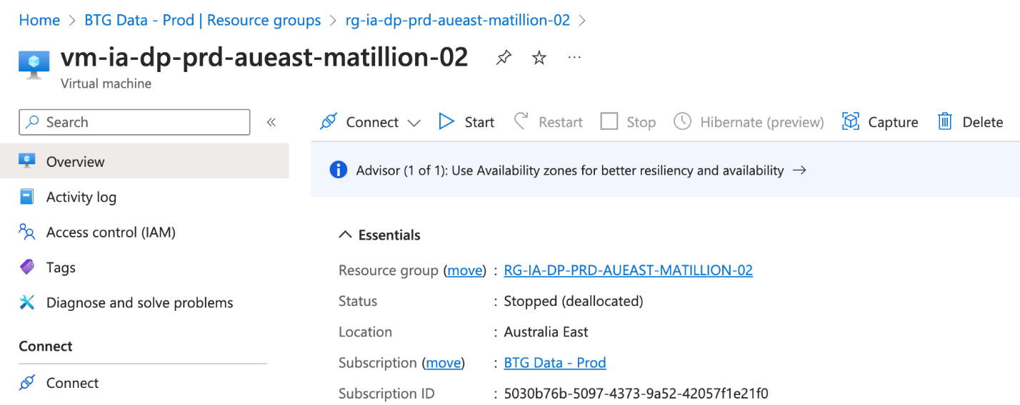

## Step 26 Enable HTTPS on Matillion ETL 1.72.4

This is to enable https on matillion-dev.npdc.govt.nz

Document <https://docs.matillion.com/metl/docs/9483725/> from Matillion shows the detail instruction of configure SSL protocols

1. Backup the original crt and key file

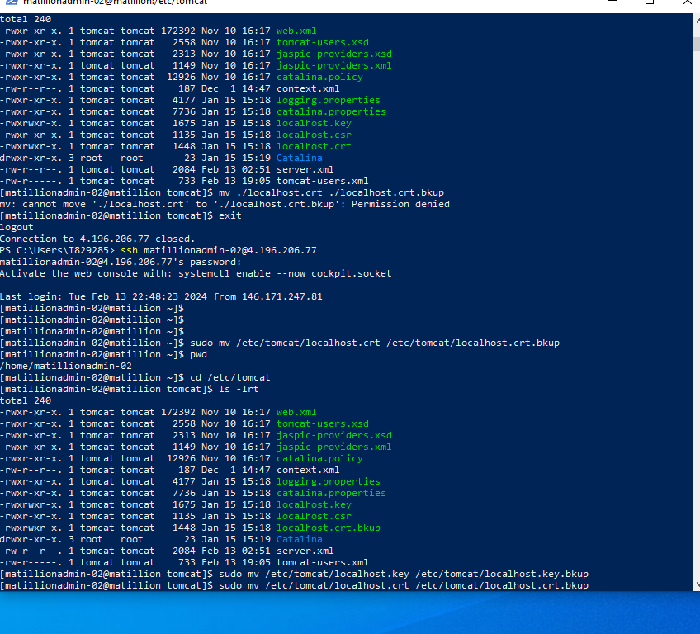

1. We can reuse the certificate and key from the original Matillion VM (e.g. Matillion ETL 1.68.7). See below figure about the certificate and key file location.

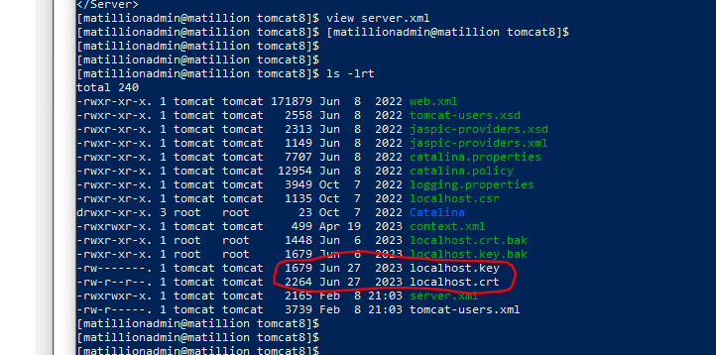

1. Download both these files into local pc .
2. Use Matillion ETL 1.72.4 UI to upload the certificate and key files. After the upload, restart the Matillion ETL 1.72.4 VM.

Go to Admin -> SSL and follow the diagram

Select Protocol for BOTH (80/443) as HTTP (80) is used for access to Matillion Job history via API extract.

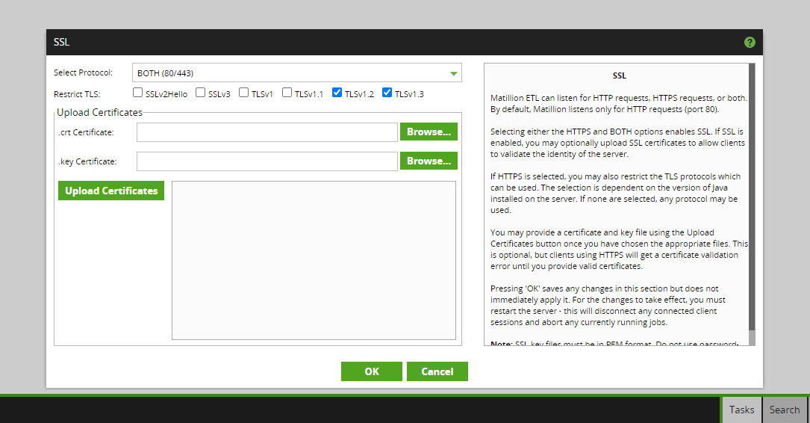

## Step 27 Restore Matillion VM shutdown policy (5pm to 7am)

Azure portal > Virtual machine > Tags edit > AutoShutdownSchedule

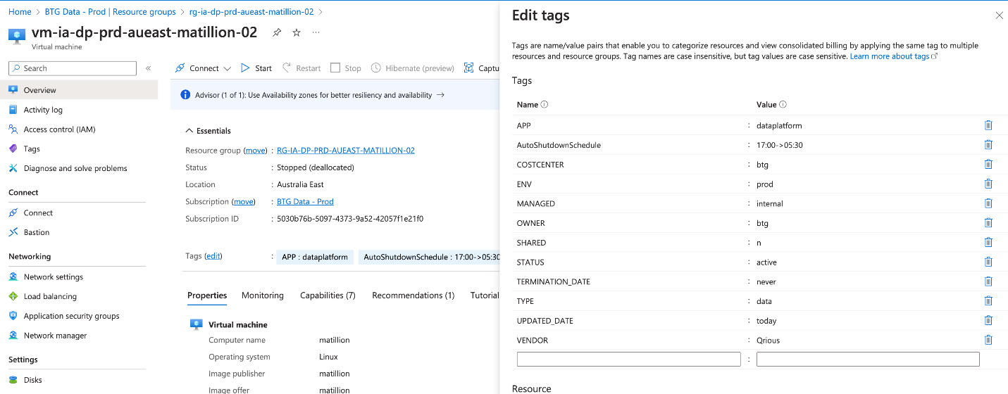

## Step 28 Re-enable schedules in Matillion VM 1.72.4

As there is no scheduled job in Matillion Development environment, there is no action for this step.

## Step 29 Test scheduled jobs works in Matillion VM 1.72 as expected

No action for this step as no scheduled job to be run.

# Detail Steps for Test environment

Since the majority of steps in the migration test environment mirror those in the development environment, the document below will only list the steps that differ from the development environment.

## Step 13 Remediate errors and warnings as needed.

When we run the batch jobs in Test environment, we encountered the following types of issue:

1. TEST_DWH objects are not created for RAMM related tables, hence the batch jobs failed to run. We copied the RAMM related tables from PRD_DWH to TST_DWH to resolve this problem.
2. Failed to access on prem server to copy file. This is due to the service account password out of date. Once the password is updated, it solves the problem.

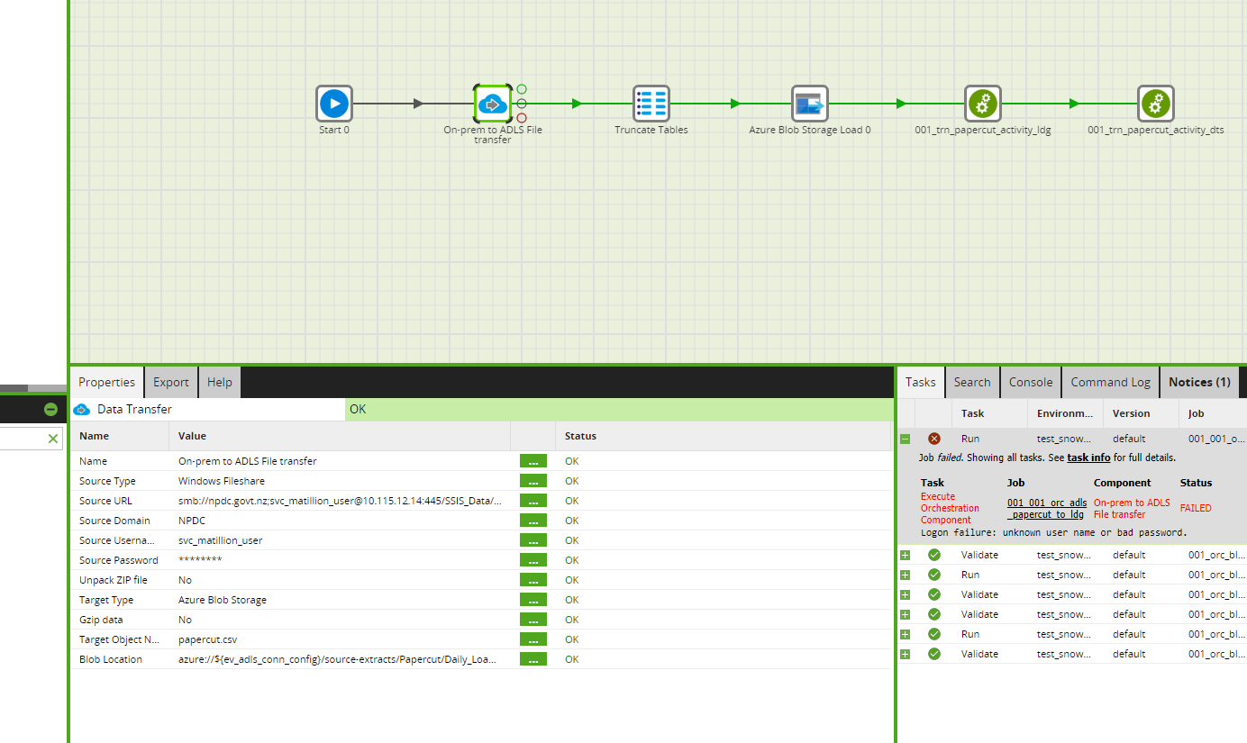

1. Fail to connect to Matillion VM via HTTP to retrieve Matillion job history.

This error occurred when we run 001_orc_matillion_job_history_extraction, the cause of this error is when we set up SSL in menu Admin -> SSL, we chose only allows HTTPS. Since the connection to Matillion VM is via HTTP, once we change to allow both HTTPS and HTTP, it solves this problem.

1. Fail to send emails via sendgrid

This is due to the IP restriction on the sendgrid side that prevents the new VM to send out email. Once NPDC infrastructure team added the new IP address to the allow list, it solves this problem. (Ask NPDC infrastructure team to provide detail)

# Detail Steps for Production environment

## Step 15 Re-enable schedules in Matillion VM 1.72.4

Since the majority of steps in the production environment mirror those in the development and test environments, the document below will only list the steps that differ from the development and test environments.

When we checked the Manage schedules function after the migration, we noticed the error of “Job not recognised”.

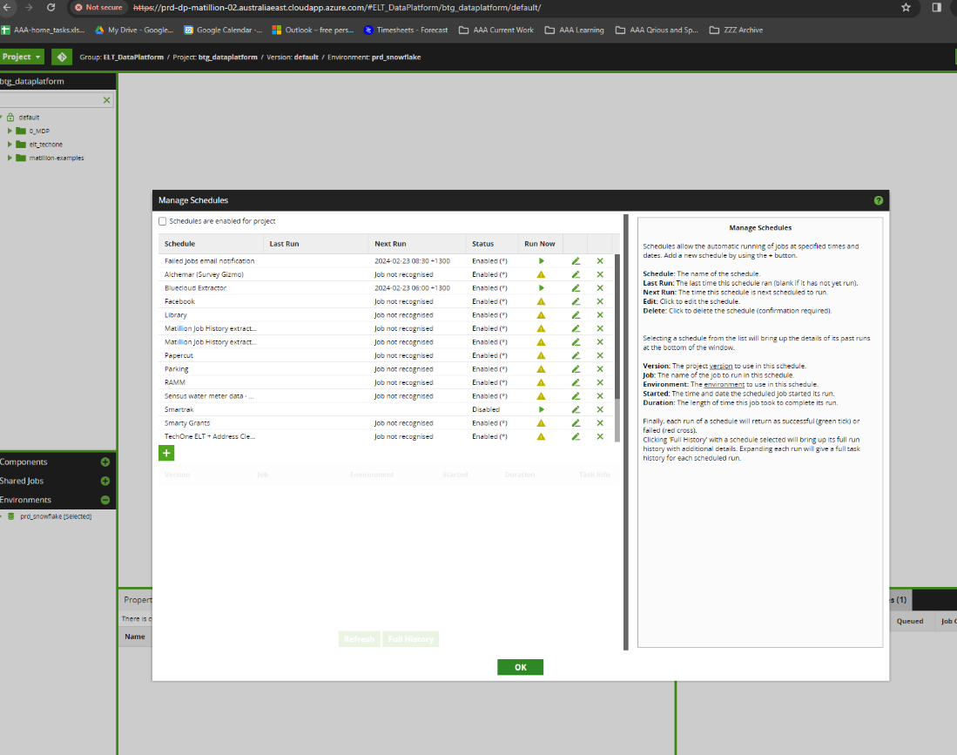

The cause of this issue is the default version is not associated with GIT branch PRD_MASTER, therefore, it could not identify the job of the schedule.

We solved this issue with the following steps:

1. Make sure the default version is associated with PRD_MASTER branch.
2. Manually updated each schedule with its expected job name.

# TO BE DELETED

Step 23 swith DNS

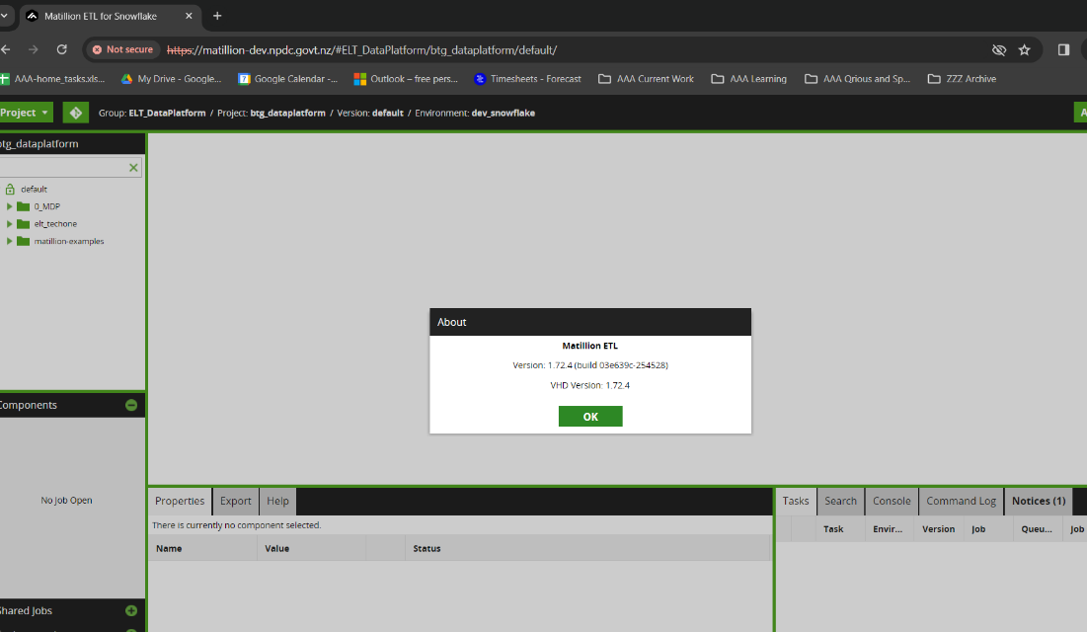

### Step 11 Remove GIT from 1.68.7

### Step 13 Enable GIT

(Azure DevOps PAT 6r62im3nlx7plhfrp4ys63bqw5ybr5m2ipqkys4uqlgdclmtumia)

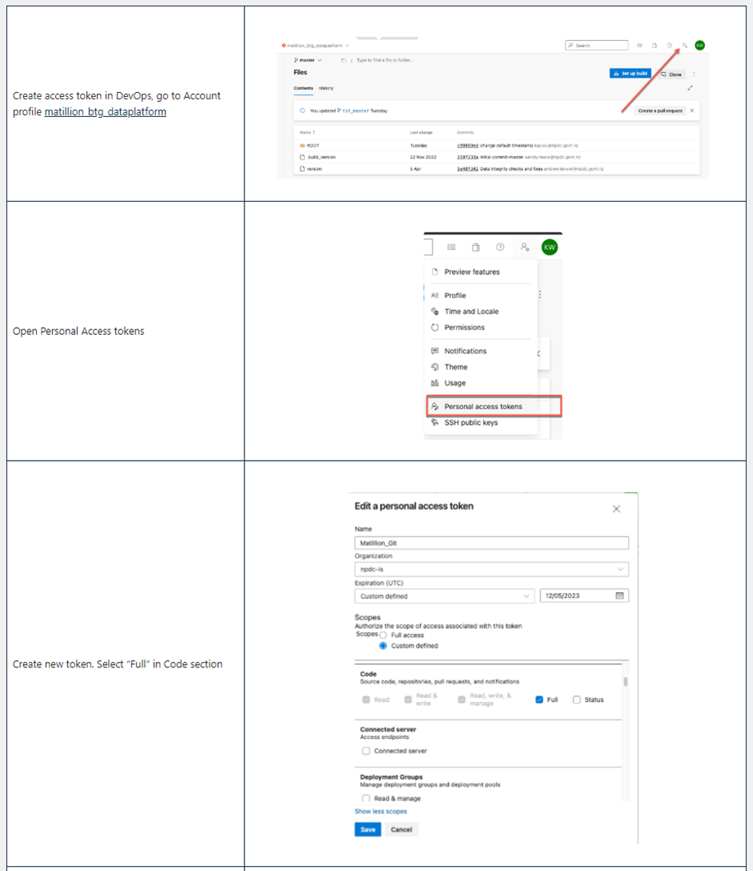

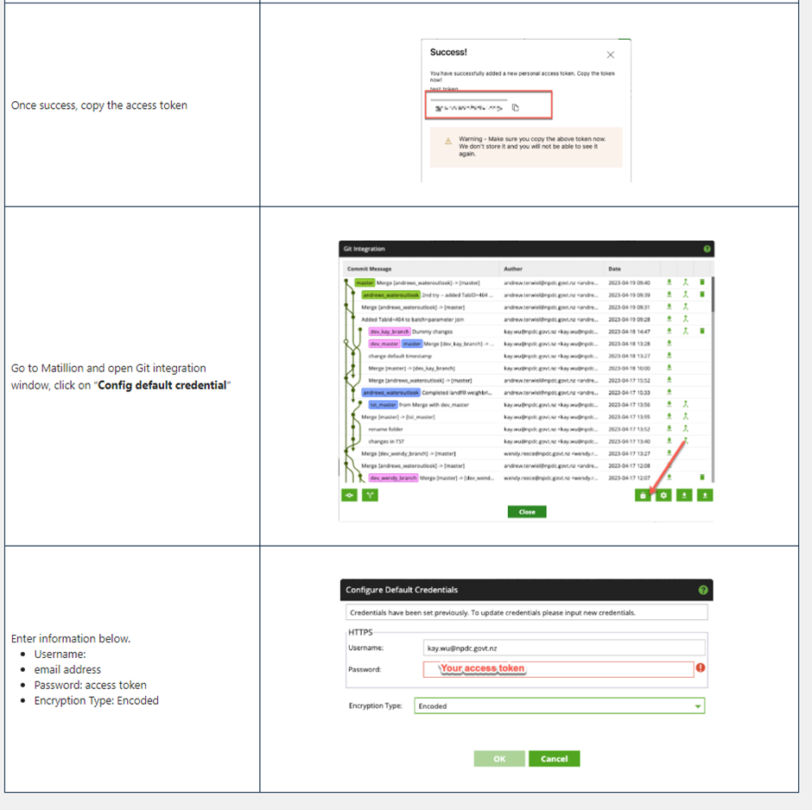

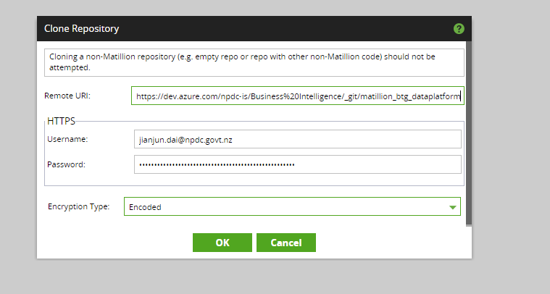

## Step Create version and checkout prd_master branch

This step creates btg_dev_MatillionUpgrade version in Matillion Development environment (version 1.68.7) and check out the prd_master branch from GIT to get ready for the batch run testing.

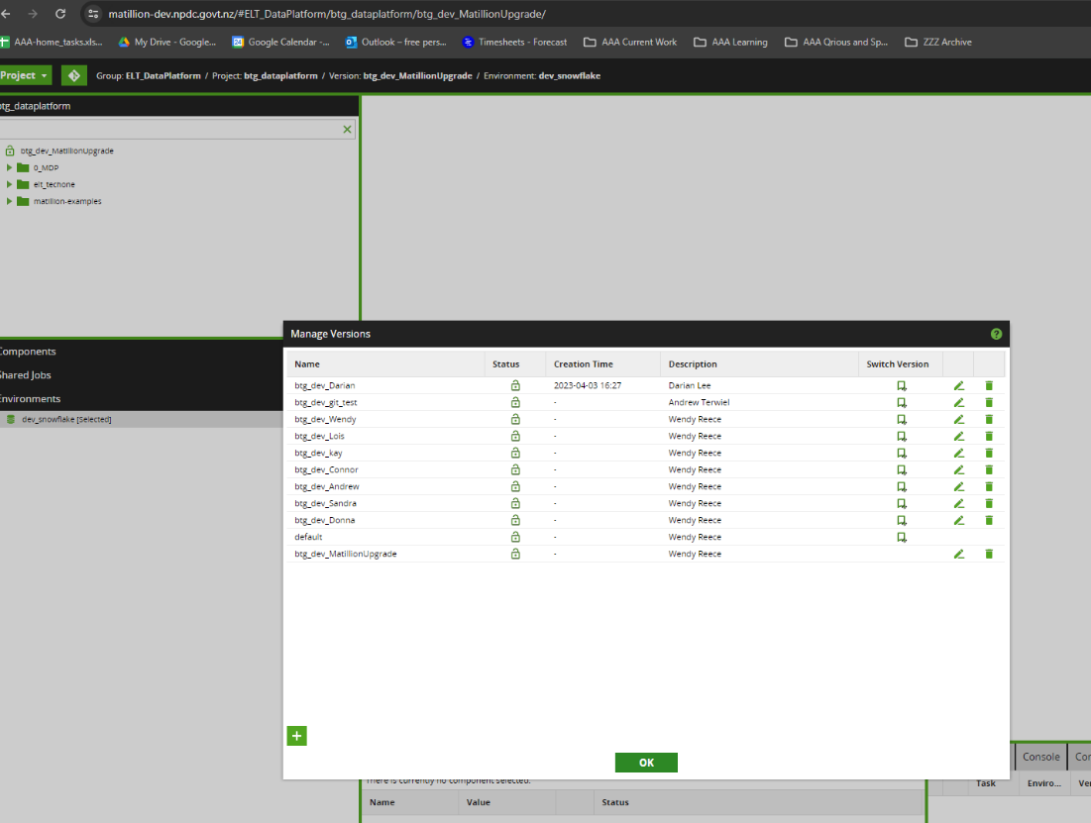

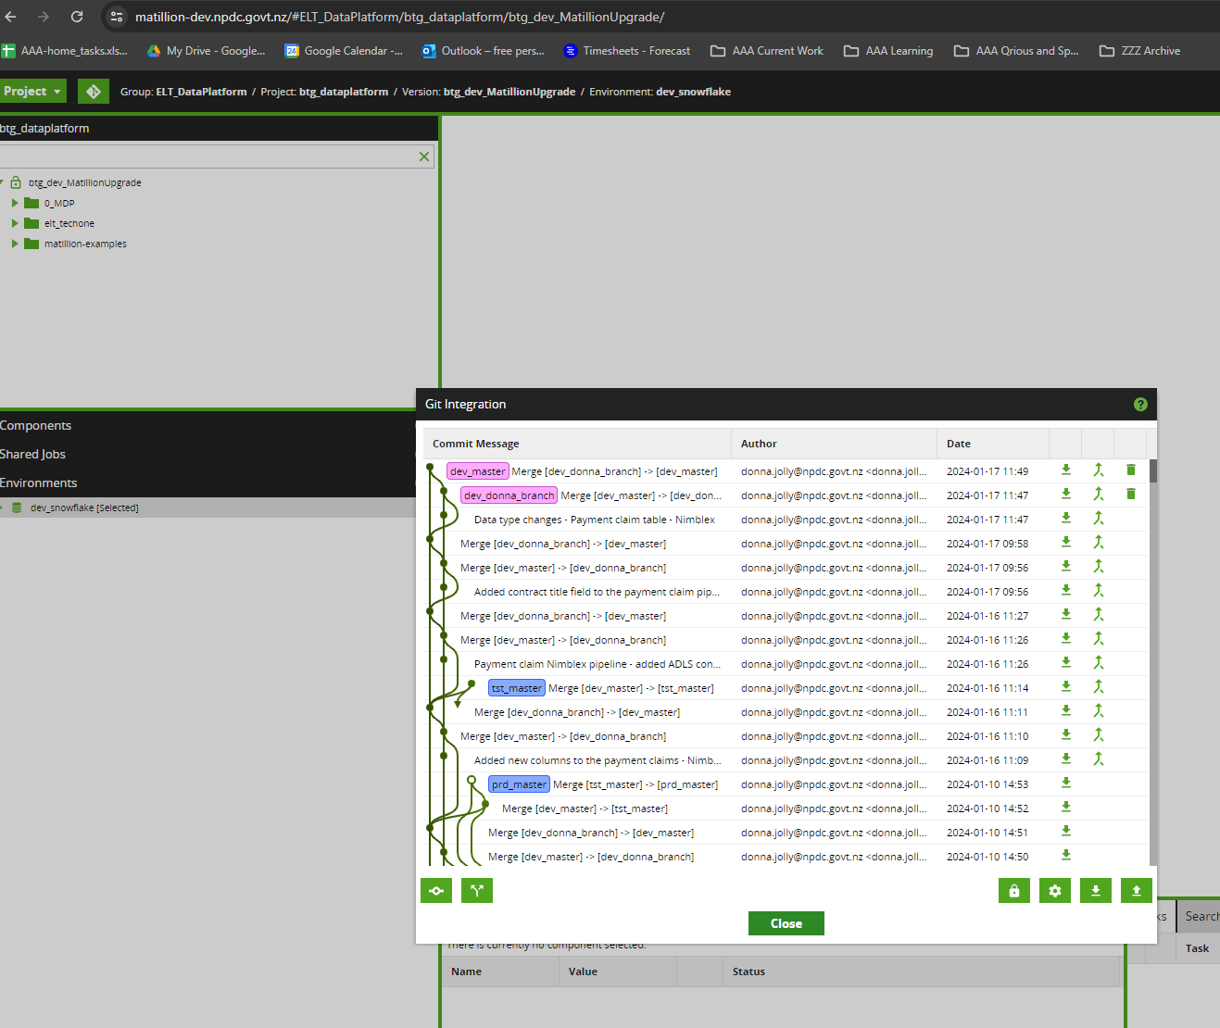

### Step 17 Identify any breaking changes

|  |  |
| --- | --- |
| 17 | Identify any breaking changes by validating and running **ALL regularly scheduled workflows**. |

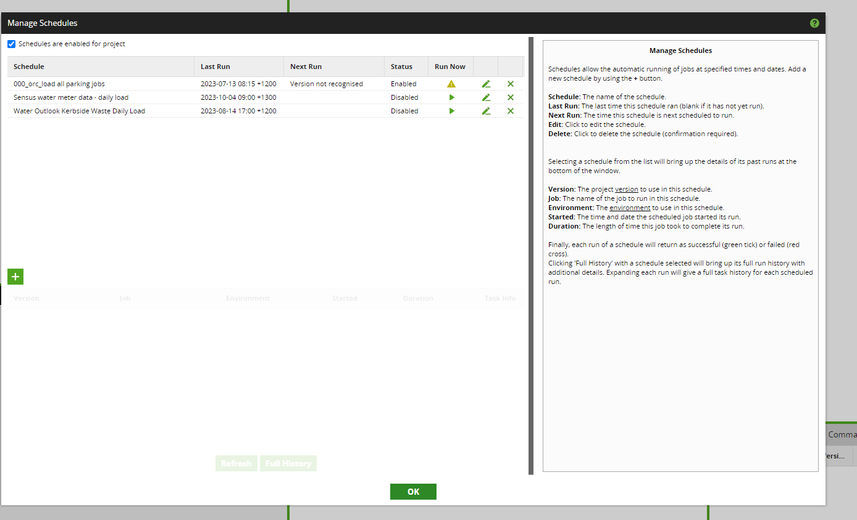

### Step list of batch jobs in production run for dev environment to run against DEV_DWH_CLONE

* 005_orc_payment_claims
  + The first time clicking off this job failed due to API extract error. This is due to the new VM dev-dp-matillion-02.australiaeast.cloudapp.azure.com is not allowed to access Azure storage location stiadpdevadls01.
  + Once engineer resolved this problem, the job completed successfully.
* 000_orc_parking_daily_job_loads
  + Completed successfully
* 001_orc_bluecloud_extractor
  + Completed successfully
* 001_orc_library_daily_job_loads
  + Got error Insufficient privileges to operate on table 'LIBRARY_EXT_PEOPLECOUNTER'. This error occurred when running it in Matillion 1.68.7 environment with DEV_DWH database, this is suspected because LANDING.LIBRARY_EXT_PEOPLECOUNTER is owned by ACCOUNTADMIN role while Matillion run as DEV_ETL_ROLE role, which has no right to operate on this table.
* 002_orc_scada_data_daily_main
  + Completed successfully
* 001_orc_Landfill_Weighbridge_main
  + Completed successfully
* 001_orc_daily_papercut_loads
  + Completed successfully
* 000_orc_ramm_daily_job_loads
  + Completed successfully
* 001_orc_grants_daily_job_loads
  + Completed successfully
* 002_orc_kerbside_waste_main
  + Completed successfully
* 001_orc_sensus_load_transformation
  + Completed successfully
* 000_orc_facebook_daily_job_loads
  + The job runs successfully after
    - update dev_dwh_clone.DATASTORE.FACEBOOK_FACT_STATS_COUNTRY set datekey = 20240115 where datekey = 20230720;
    - It looked like for a too long period of time (eg from 20230720 to current), the job is no able to run successfully.
    - Recreate external function DEV_DWH_CLONE.DATASTORE."CALCULATE_SENTIMENT"("STR" VARCHAR(16777216)) from its definition in DEV_DWH, as Snowflake zero copy cloning does not support clone external function.
* dj_00_orc_run_techone_daily
  + Completed successfully after 9 hours and 15 minutes
* 001_orc_matillion_job_history_extraction
  + Completed successfully
* 001_orc_failed_jobs_notification
  + Completed successfully

### Step 19 Update Matillion VM 1.72 Environment(s) to refer to the live (DEV) environment rather than the clone one. (i.e development)

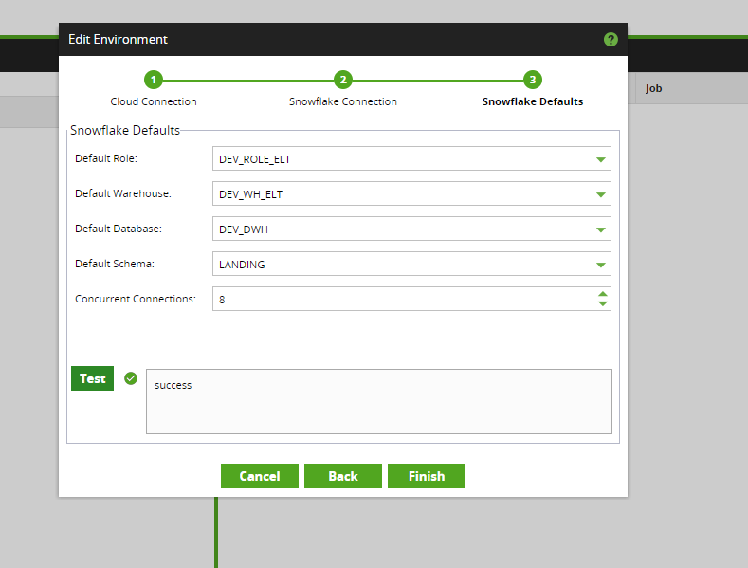

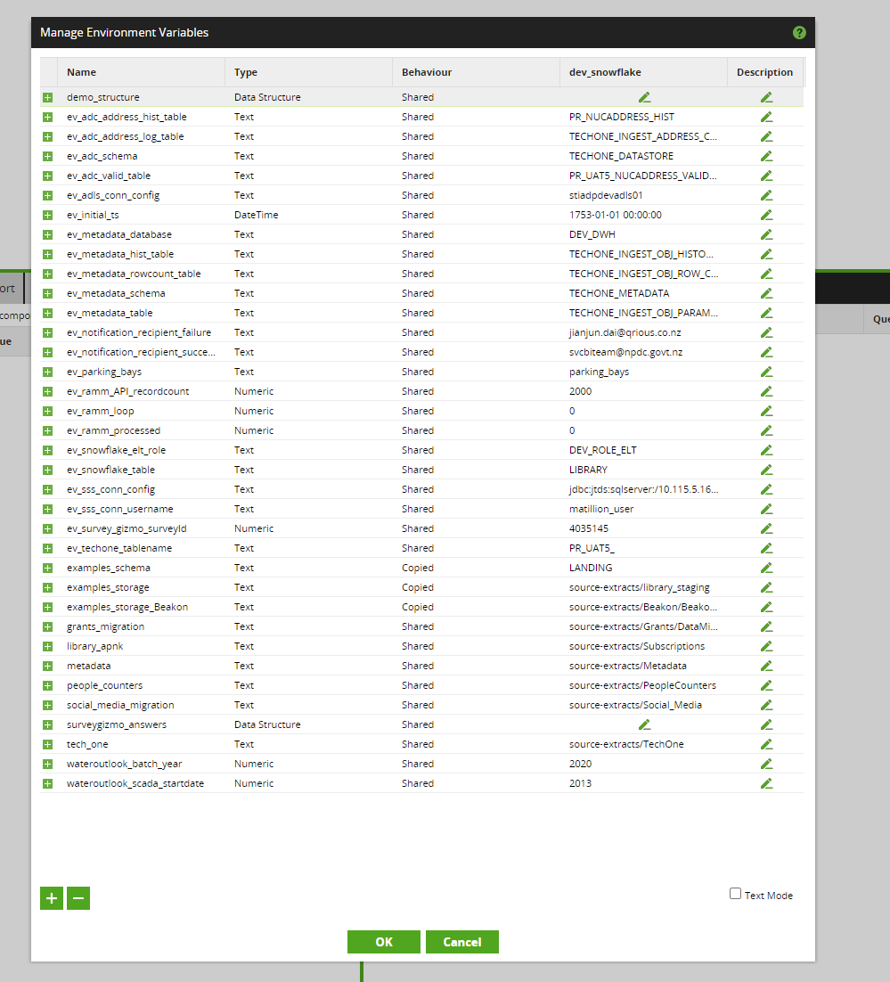

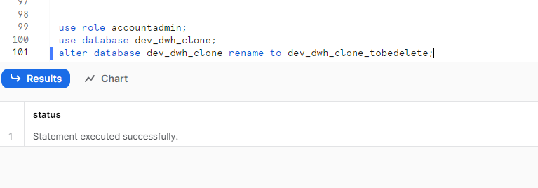

### Step 20 In Matillion VM 1.72, run all regularly scheduled workflows against DEV_DWH database.

005_orc_payment_claims (Success, 13s)

000_orc_parking_daily_job_loads (Success, 9m )

001_orc_bluecloud_extractor (Success, 12m)

001_orc_library_daily_job_loads (Got error Insufficient privileges to operate on table 'LIBRARY_EXT_PEOPLECOUNTER', this may due to the fact that LANDING.LIBRARY_EXT_PEOPLECOUNTER is owned by accountadmin while Matillion run as DEV_ETL_ROLE, which has no right to operate on this table)

002_orc_scada_data_daily_main (Success, 40m)

001_orc_Landfill_Weighbridge_main (success, 2s)

001_orc_daily_papercut_loads (success, 1s)

000_orc_ramm_daily_job_loads (Success, 40m)

001_orc_grants_daily_job_loads (Success, 59m)

002_orc_kerbside_waste_main (Success, 40s)

001_orc_sensus_load_transformation (Success, 30s)

000_orc_facebook_daily_job_loads (Success, 7m)

dj_00_orc_run_techone_daily (, )

001_orc_matillion_job_history_extraction (Success, 40s)

001_orc_failed_jobs_notification (Success, 2s)

## Reference 1: VM access detail

The Matillion 1.72.4 VM [matillionadmin@20.5.77.100](mailto:matillionadmin@20.5.77.100)

## Reference 1: Timetravel setting check

show parameters like '%DATA_RETENTION_TIME_IN_DAYS%' in schema PRD_DWH.INFORMATION_SCHEMA ;

show parameters like '%DATA_RETENTION_TIME_IN_DAYS%' in schema PRD_DWH.LANDING ;

show parameters like '%DATA_RETENTION_TIME_IN_DAYS%' in schema PRD_DWH.MDP_METADATA ;

show parameters like '%DATA_RETENTION_TIME_IN_DAYS%' in schema PRD_DWH.STAGING ;

show parameters like '%DATA_RETENTION_TIME_IN_DAYS%' in schema PRD_DWH.TECHONE_DATASTORE ;

show parameters like '%DATA_RETENTION_TIME_IN_DAYS%' in schema PRD_DWH.TECHONE_LANDING ;

show parameters like '%DATA_RETENTION_TIME_IN_DAYS%' in schema PRD_DWH.TECHONE_METADATA ;

show parameters like '%DATA_RETENTION_TIME_IN_DAYS%' in schema PRD_DWH.DATASTORE ;

show parameters like '%DATA_RETENTION_TIME_IN_DAYS%' in schema PRD_DWH.PRESENTATION ;

select table_catalog, table_schema, retention_time, count(*)

from information_schema.tables

where table_schema not in ('INFORMATION_SCHEMA')

group by 1, 2, 3

order by 1, 2, 3

;

TABLE_CATALOG TABLE_SCHEMA RETENTION_TIME COUNT(*)

PRD_DWH DATASTORE 10 178

PRD_DWH LANDING 1 356

PRD_DWH LANDING 1

PRD_DWH MDP_METADATA 1 6

PRD_DWH PRESENTATION 10 113

PRD_DWH PRESENTATION 4

PRD_DWH STAGING 1 12

PRD_DWH TECHONE_DATASTORE 1 3690

PRD_DWH TECHONE_LANDING 1 1421

PRD_DWH TECHONE_METADATA 1 5

---- Start of TEST upgrade ----

IN TEST MATILLION Environment:

* 005_orc_payment_claims
  + Completed successfully
* 000_orc_parking_daily_job_loads
  + Modifications (add parking_bays table and environment variable, with PRD_MASTER code still failed)
  + Failed due to PARKING_FACT_PARKING_STAYS_V2 table definition is not matching the code in TST_MASTER (NOT UPGRADE RELATED)
  + desc table tst_dwh.staging.PARKING_FACT_PARKING_STAYS_V2;
  + desc table dev_dwh.staging.PARKING_FACT_PARKING_STAYS_V2;
  + desc table prd_dwh.staging.PARKING_FACT_PARKING_STAYS_V2;
* 001_orc_bluecloud_extractor
  + Failed at sending email step, checked it was working in original TEST matillion.
  + The emailing issue is fixed now and job rerun successfully.
* 001_orc_library_daily_job_loads
  + Completed successfully.
* 002_orc_scada_data_daily_main
  + Failed at sending email step, report success.
  + Emailing issue is fixed.
* 001_orc_Landfill_Weighbridge_main
  + Failed at sending email step, report success
  + Emailing issue is fixed.
* 001_orc_daily_papercut_loads
  + Run with PRD_MASTER code, failed at On-prem to ADLS File transfer. This failure also happens in the original Matillion-Test environment. (NOT UPGRADE RELATED) found out this is due to the service account password routinely changing, updated the password and the job runs successfully.



* 000_orc_ramm_daily_job_loads
  + Running with PRD_MASTER
  + failed at On-prem to ADLS File transfer. This failure also happens in the original Matillion-Test environment. (NOT UPGRADE RELATED), found out this is due to the service account password routinely changing, updated the password and the job runs successfully.
* 001_orc_grants_daily_job_loads
  + Running with PRD_MASTER
  + Failed as below, missing table columns (NOT UPGRADE RELATED)

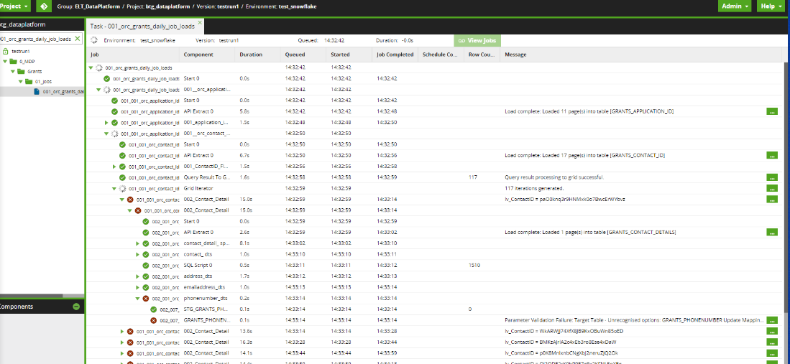

* 002_orc_kerbside_waste_main
  + Failed at sending email step, report success
  + Emailing issue is fixed.
* 001_orc_sensus_load_transformation
  + Failed at sending email step, report success
  + Emailing issue is fixed.
* 000_orc_facebook_daily_job_loads
  + The job runs failed due to UDF does not exist
    - TST_DWH.DATASTORE."CALCULATE_SENTIMENT"
    - TST_DWH.LANDING."CALCULATE_SENTIMENT"
    - None of them can be recreated due to the external file stage does not exist.
* dj_00_orc_run_techone_daily
  + Running
* 001_orc_matillion_job_history_extraction
  + Failed with API call
  + Fixed once allow both HTTP and HTTPS on SSL config
  + 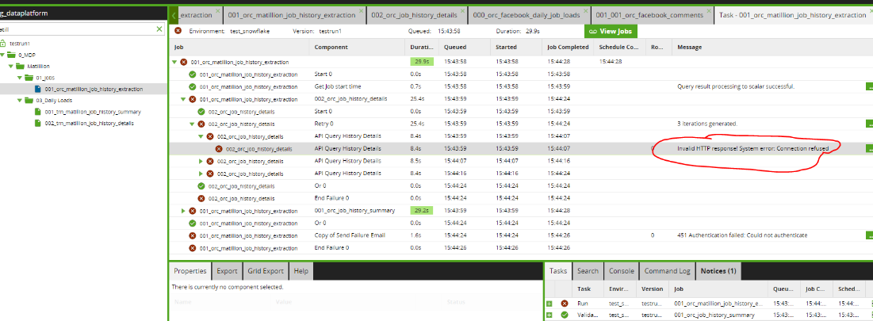
* 001_orc_failed_jobs_notification
  + Completed successfully

---- End of TEST upgrade ----

---- Start of PROD upgrade ----

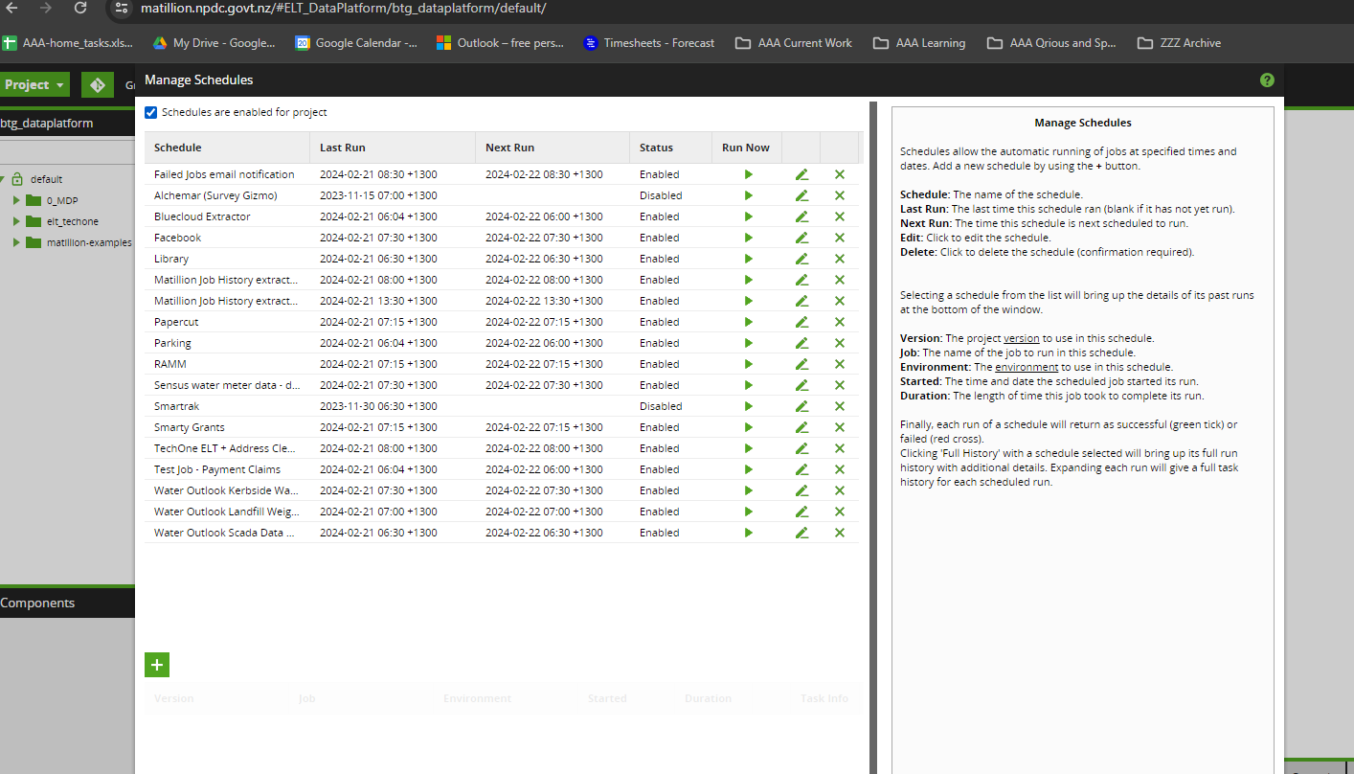

-- Production Migration

Step 5

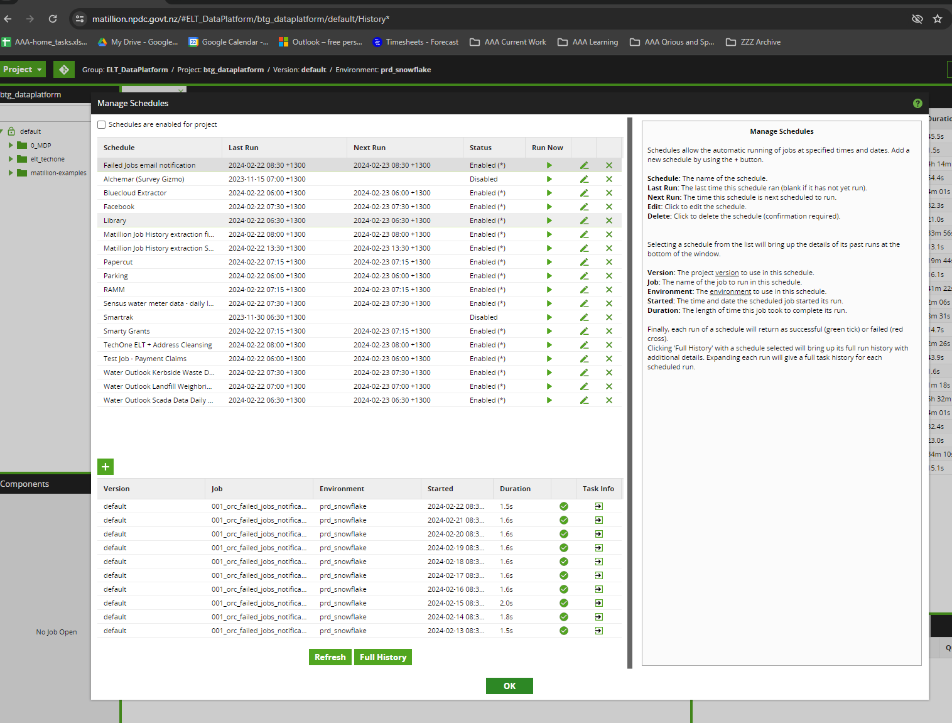

Step 7 remove git

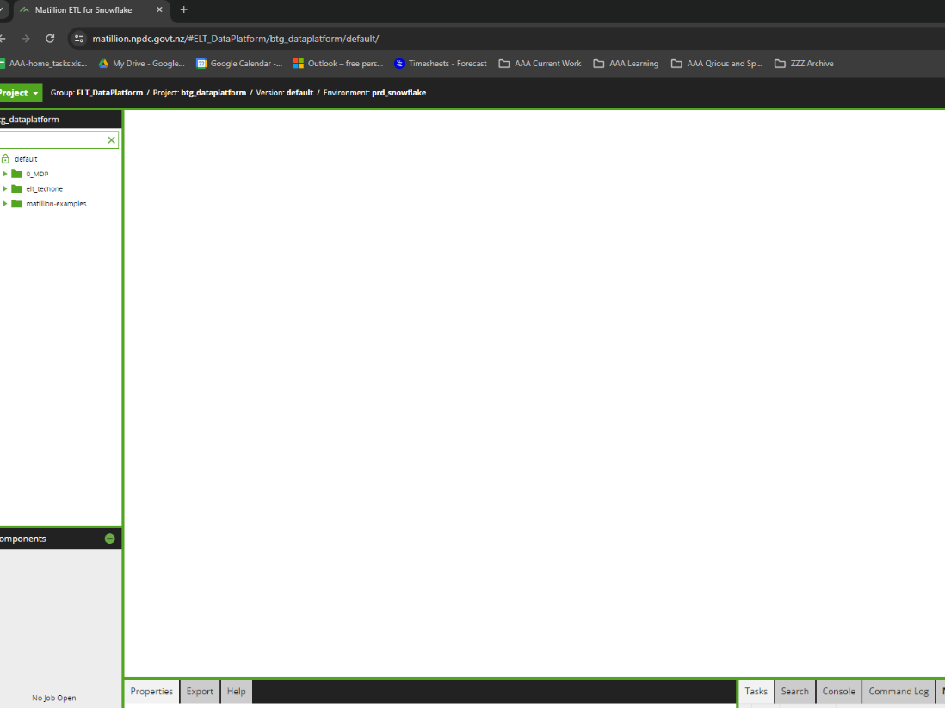

Step 8:

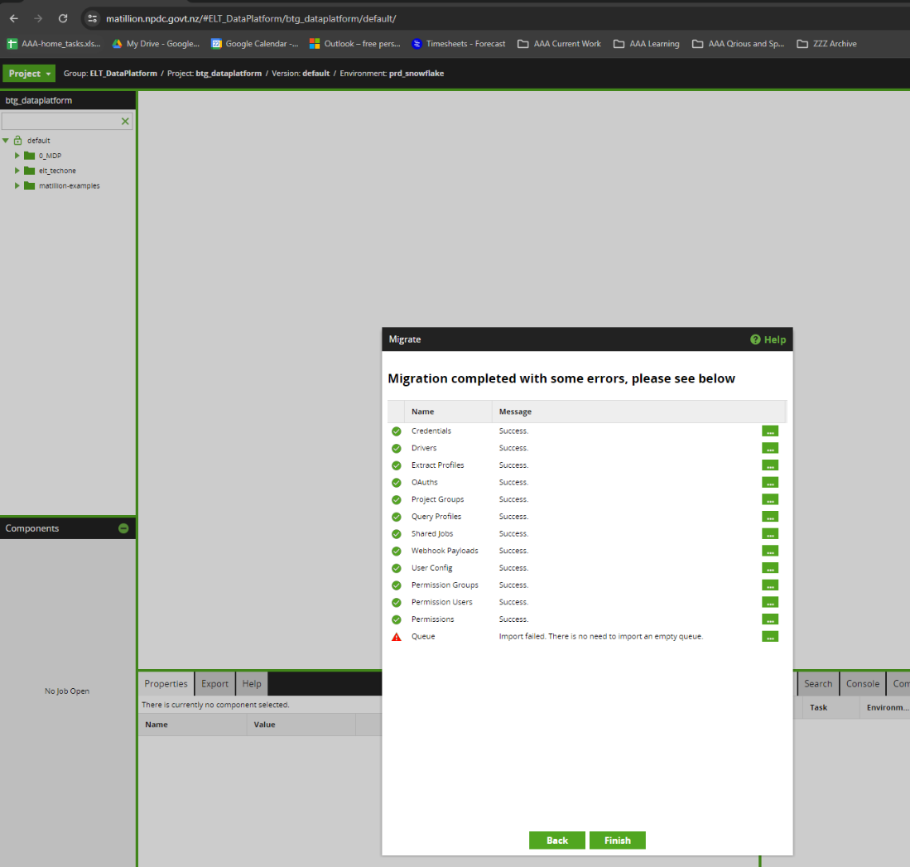

Step 9:

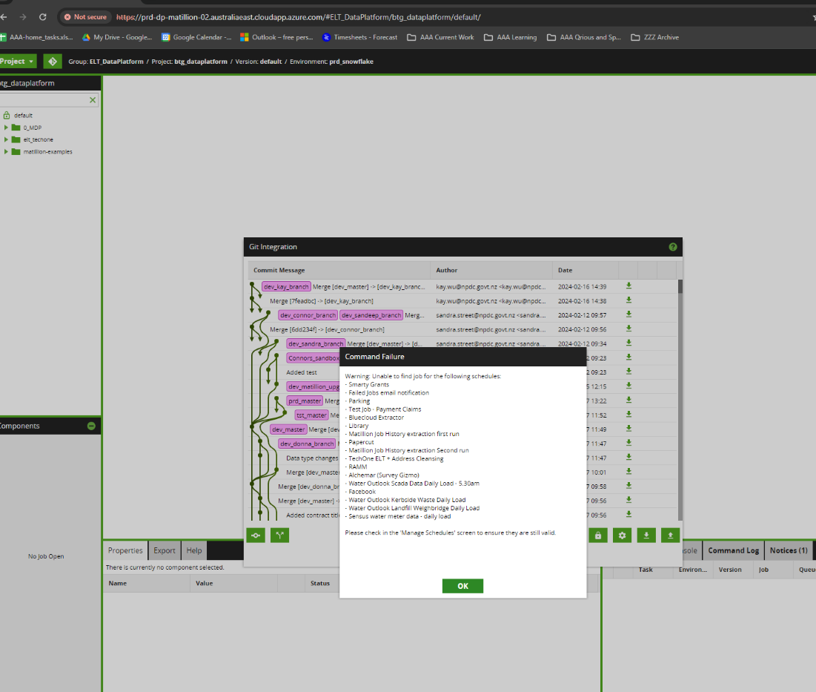

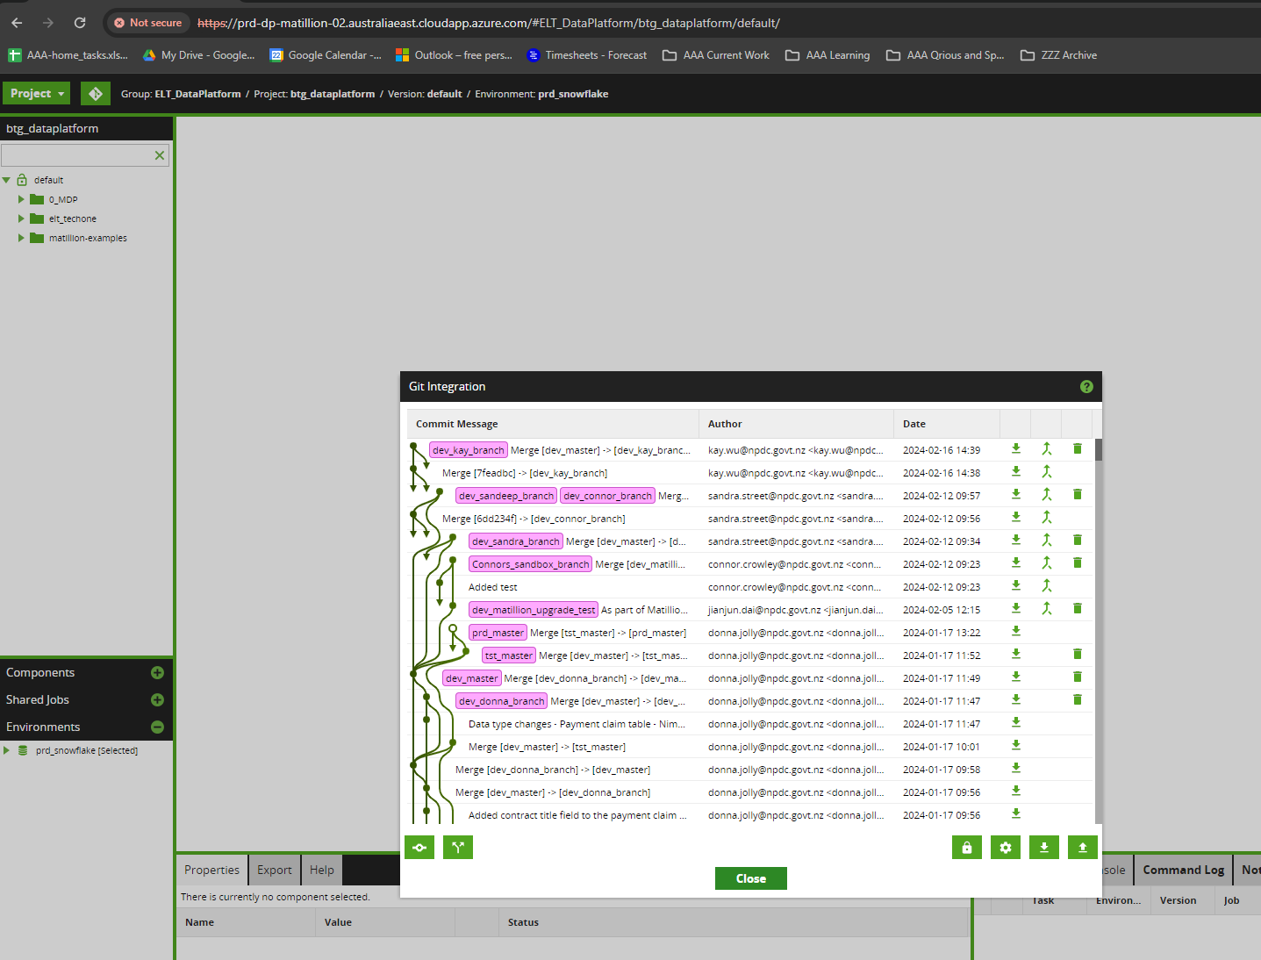



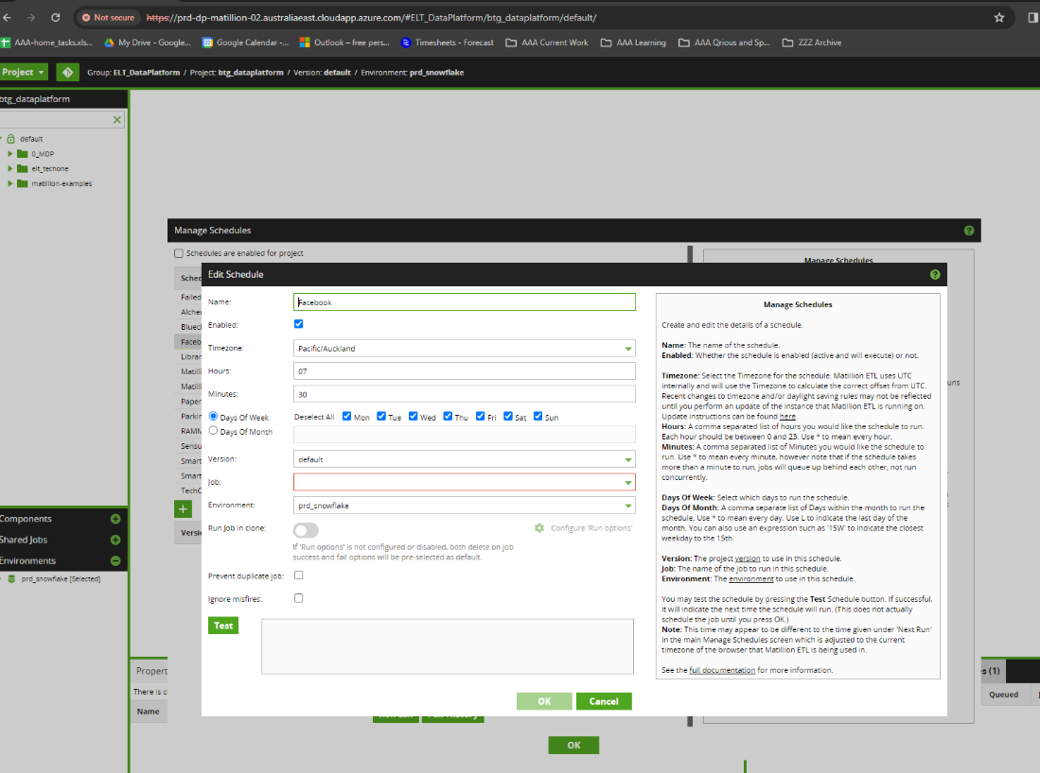

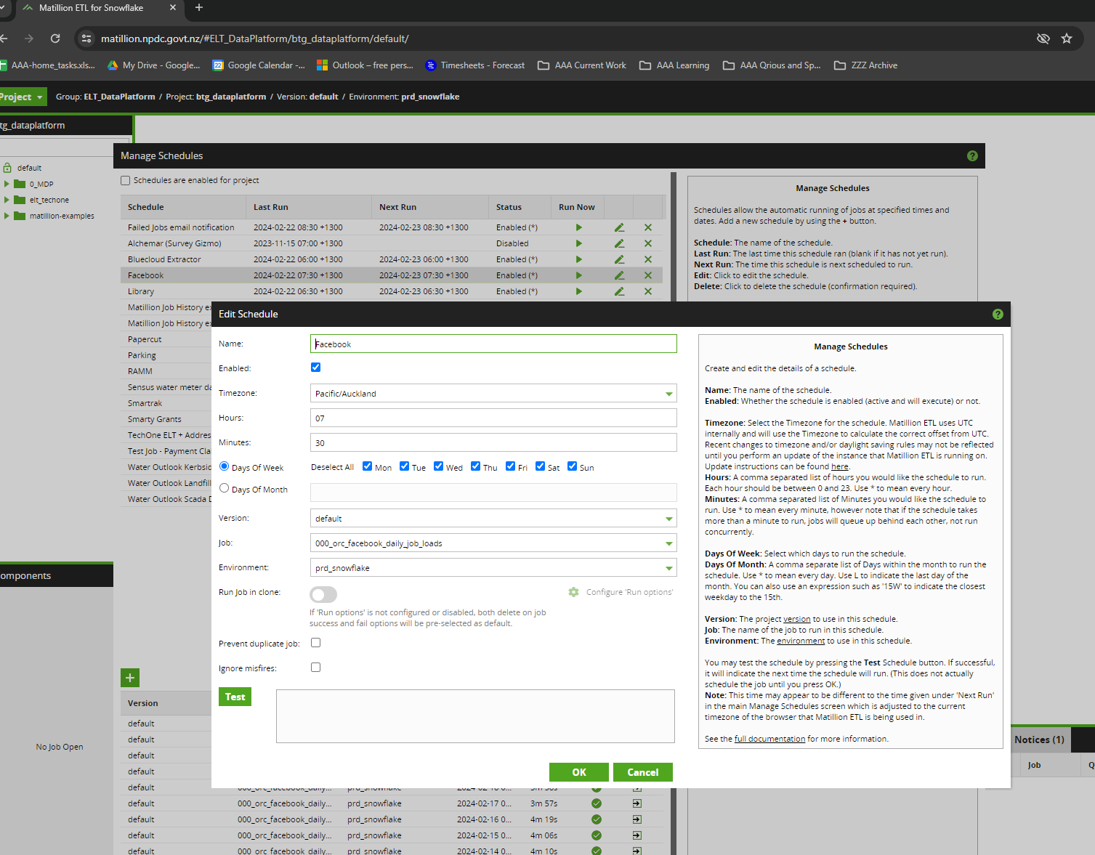

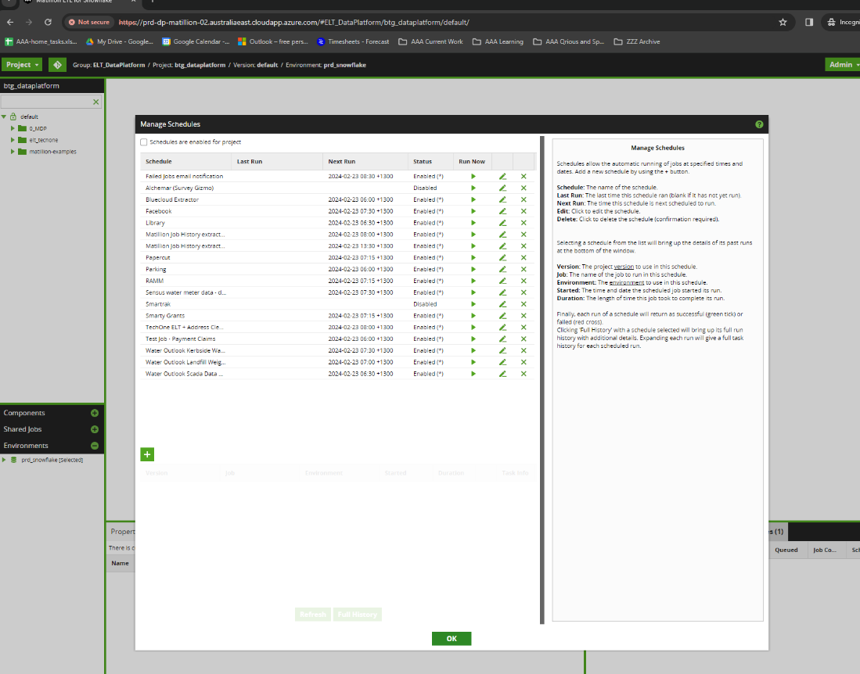

Step 11

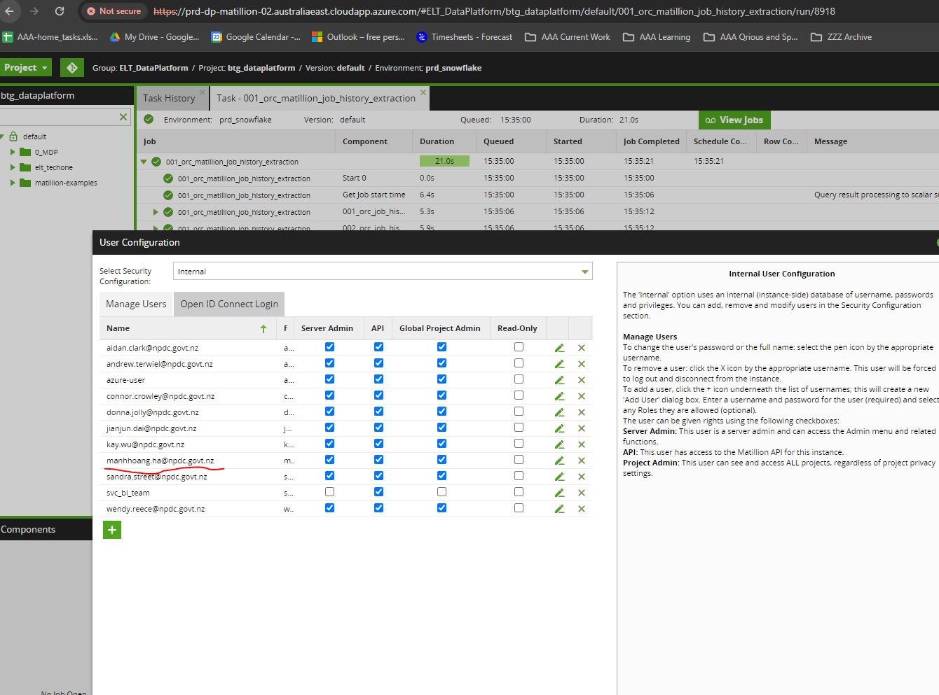

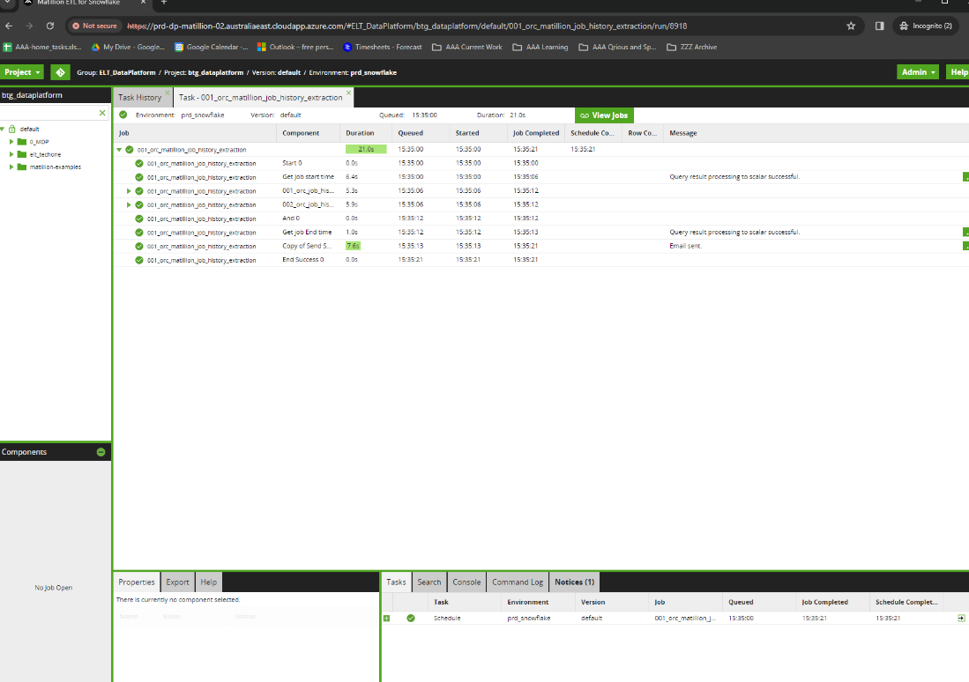

Step 15

